Filed by R1 RCM Inc.
Pursuant to Rule 425 under the Securities Act of 1933,
as amended, and deemed filed pursuant to Rule 14a-12
under the Securities Exchange Act of 1934, as amended
Subject Company: R1 RCM Inc.
Commission File No.: 001-34746
Date: February 18, 2022

The following is a complete transcript of R1 RCM Inc.’s fireside chat and corresponding presentation held on February 18, 2022 at the SVB Leerink 11th Annual Global Healthcare Conference.

R1 RCM Presentation at SVB Leerink 11th Annual Global Healthcare Conference

February 18, 2022

Moderator
•Stephanie Davis, SVB Leerink Healthcare Technology Analyst

Presenters
•Joseph Flanagan, President & CEO
•Rachel Wilson, CFO & Treasurer
•Atif Rahim, SVP Investor Relations

PRESENTATION

Stephanie Davis
Hello everyone and welcome back. We continue the 11th Annual SVB Global Healthcare Conference. It is my pleasure to introduce R1 RCM, one of my top picks, and we have the whole team here. We've got President and CEO Joe Flanagan, CFO and Treasurer Rachel Wilson and the head of IR Atif Rahim. Guys, thank you for joining the program.

Joseph Flanagan
Thanks for having us, Stephanie.

Stephanie Davis
I am especially thrilled that you guys are here, not only because Atif had to go through planes, trains and automobiles to get home, but also because you guys just had your print. Could you tell us a little bit more about yesterday's earnings?

Joseph Flanagan
Yeah, where would I start? On full year ’21 we're really proud of everything we got done. If you look at it financially, both on the top line and bottom line, well ahead of the expectations we had starting the year, so encouraged on those dimensions. Significant advancement in our capabilities, whether that be on the dimension of automation, whether that be on the VisitPay acquisition, and then as we talked about yesterday on the call, we're really encouraged with the pipeline. So progression of the pipeline and some near term activities that we've got that we're very, very excited about, relative to near term contracts.

Stephanie Davis
You guys have had a whirlwind ride too, it opened at down 10, now we're, looks like we're up 3% now so God knows where things are going. There was a little bit of debate around your 1Q guidance, I think drove some of that. So can you walk us through the puts and takes?

Joseph Flanagan
Yeah, on 1Q it's a little bit of an interesting quarter, and guidance was 85 to 90, and we wanted to make sure we highlighted for the investment community, some unique dynamics we've got in 1Q above our normal course operations. These are dynamics that we planned around, we understand, and are fully incorporated into our full year guidance.

But the two that I would highlight is spend with external advisors related to the large contract we've talked about. And as you think about what is that category of spend, given the size of this contract, and the structural nature of what we do, those two things, you know, this is a $2 to $3 million spend in Q1 that we'll see play through. Primarily around legal advisors, regulatory advisors, those types of things. Now we have in every one of our contracts, but just given the size of this, it has an outsized impact on 1Q. And then the second is just our employee related healthcare costs. They're up roughly 5 million, quarter over quarter. And that's just related to utilization and kind of working out of the COVID tail so to speak, and some of the comparisons. Both of those are known to us, they're included in our full year guidance, and they're not things we expect to repeat. So when you when you normalize for that, we feel really excited about execution out of the start of the year, both in 1Q and looking beyond that.

Stephanie Davis
This may be more of a Rachel question, but is there any way to size the kind of utilization headwind that you're going to see from Omicron and the three month lag you guys experienced in net patient revenue?

Rachel Wilson
Yeah. So as we look to the net patient revenue on our base fees, given how we bill for that, there's that three month lag so we really do have very good visibility through 1Q. And as we've talked about, we really model very extensively what's happening by the different care settings and what kind of volume we are seeing. And that's really our leading indicators as well, as we're tracking that as we think about what our base fees are going to be throughout the year. So I think we feel quite confident around how that will project. I think what Joe was referring to too is much more about our own employee utilization of healthcare and if you compare to a year ago, Q1 to Q1, we are forecasting that we'll see that increase and so that's something that we have as our projections, you know, well modeled in.

Stephanie Davis
I get that I mean, on the core net patient revenue headwind, is there any way to size that just when we think about the calm?

Joseph Flanagan
I think we see probably on the balance of the year, net patient revenue to be a tailwind, you know, as we think about

Stephanie Davis
You’re seeing more utilization right?

Joseph Flanagan
Yeah, exactly. And we definitely see that as we look to 2022 on a full year basis without a doubt. And as I noted on the call yesterday, I'm particularly encouraged that the care setting that was lagging the most was the ED care setting, and we're seeing that follow the other care setting. So we feel good about, as we look out over the course of year, we feel good about that and we feel good about the team's readiness to execute, converting that to cash because that's the most important thing for us. We've got to convert that leading indicator of revenue, to cash to have it flow through our base fees, and the teams are in great shape along those lines.

Stephanie Davis
Hopefully not just for you guys being my top pick but so I can get out of this one room that I've been in the entire past two years, we’ll start to see things go back.

Joseph Flanagan
We could not agree more Stephanie.

Stephanie Davis
Shifting gears a bit, I do want to talk about Cloudmed, because it feels like this quarter we just had was you guys kind of setting it up for a much more exciting 1Q and 2Q print, as you talk about the $10 billion win and the Cloudmed deal. Could you just give us a little rehash of your relationship with the Cloudmed asset and your rationale for combining?

Joseph Flanagan
Yeah I mean, listen, we've long respected, admired what they've done over the past four or five years in their journey on a standalone basis. We have high regard, prior to ever engaging in discussions with them along potential acquisition, but high regard for how they approach solving this problem. And this is an area that is of high importance to our customers. So when you think about revenue and ensuring that hospitals are getting paid in the face of a very complicated payor contracting environment, that they're able to navigate that complexity on behalf of their mission. This is a high degree, it's at a CEO CFO level visibility, and the nexus of that importance and Cloudmed’s capability, we've been very impressed with how they've approached this and that was really I would say some of the seeds that formed, so to speak, and ultimately led to where we are right now. The other thing I would say Stephanie there’s just not a lot of technology driven high quality assets in the Revenue Cycle space. And so, from our standpoint, looking out over the next five years or so, strategically combining our capabilities with theirs in the face of what we think is a big market opportunity in front of us, we really liked that positioning for us together, to play offense into the growth opportunity that we think is there. And so those were some of the factors for us that got us excited and as I said right now, every time I spend time with that team, I get more excited about our opportunities to grow and also to solve problems with technology.

Stephanie Davis
The technology component, Joe, I think is really important, that point you made. Because when I talk to folks about Cloudmed, the asset, a lot of times they say, ‘Oh, this is modular solutions, doesn't R1 RCM also have a modular solution suite?’ So let's maybe talk a little bit through how they're differentiated. The way I have it viewed in my head, and tell me if I'm wrong and tell all the people in the line that I'm wrong too, but the way I think about it is that this is a more tech enabled solution. So it's more automation more prospective and it allows you to go to the smaller ticket items that someone like you as a manual revenue cycle management player probably just wouldn't be able to touch as much. Is that fair to say? Or is there other components we should call out?

Joseph Flanagan
Yeah, I think it's multi-dimensional. It is fair to say. So they are more tech enabled in this category of offering compared to where we are in our journey. But maybe more importantly, they also have a much more expansive data set and rule set and so what that does is it opens up all facets of the market meaning they have the rule set across all payors across all geographies. Our rule set and our data set is born out of our installed base which is not as significant as theirs, so they're credibly able to serve the entire market, in our opinion better than anybody. Second thing the automation opens up the market dimension on sizing. So to your point. Now, I want to unpack modular a bit. We have modular offerings, without a doubt. The reality is for us, is because the pipeline has been growing the opportunities that presented themselves on the end-to-end basis, the majority of our mindshare commercially and supporting that commercial pursuit is in that end-to-end offering. Now we know and in fact, if I look back at ‘21, and even in Q1 on a standalone basis, our modular opportunities are really progressing nicely. And so what I'm very excited about is having within the company scaled mindshare on the modular end of the market and scaled mindshare on the end-to-end side of the market. And post close, three modular offerings that we're going to put into the Cloudmed commercial engine, the VisitPay platform, our physician advisory services offering, and the third is going to be our Entri platform. And their commercial team has a multiyear demonstrated track record to attach new sales to their installed base, and they understand these offerings very well. They speak the same language, they understand how to communicate the value of prop, etc.

Stephanie Davis
I'm going to go completely off script which I know you probably hate Atif, because I've been like completely off script for a lot of this, but going in a totally different direction. You mentioned the VisitPay component could that get you more into a Phreesia-esk side of the business and kind of change your yield proposition?

Joseph Flanagan
What I would say with VisitPay and Entri, so if you think about the functionalities that sits in those two technology platforms, you have scheduling, digital intake, all of the registration and financial counseling kind of requirements and all of the patient payment offerings. We don't have you know, our business model is not set up with the number of feet on the street, so to speak, to really touch the end market that would be wanting, -- Cloudmed has that. So that is, in my opinion, a big opportunity to accelerate growth and unlock TAM for those platforms that we probably wouldn't have been able to do on our own for the foreseeable future, just given the demand we see right now in the end-to-end market.

Stephanie Davis
So the way we should think about Cloudmed is you're able to go into these lower ticket cases that you weren't before, you have more feet on the street so you could actually get a lot more amplification of these platforms you are building. Is there anything that we can read through to your take rate as you're able to energize both those areas of the business?

Joseph Flanagan
Well, I think when we announced the deal, one of the things I would point to on take rate is, we're very comfortable with a 20% guide on our modular growth. And we've got to unpack that more as we get the deal closed and dialogue with more specificity around that with you and all of your partners. But that's what I would point to. And what I want to say Stephanie is, we definitely will open up the lower end of the market, but Cloudmed is in 47 to 48 of the top 50 health systems with a preexisting very strong commercial relationship. So it's going to open up all facets of this market in that modular channel.

Stephanie Davis
Let's double click on that a little bit. You have been talking about the upmarket for about six months now. You've gotten more involved with Cloudmed. What drives their strength of relationships in that upmarket client that you haven't been able to penetrate as much?

Joseph Flanagan
Well, one is capacity. So we just don't have kind of the, we don't have that commercial channel built as we sit today. We could build it, it would take us some time. And then the second thing I would say, and I would highlight this as a superior attribute unique to Cloudmed, in my opinion scanning the market, is the capability of their commercial engine. They have a depth of domain expertise, commercially, on the revenue cycle space at large that allows that team to establish credibility with the provider base. And that for me, as opposed to a generalist commercial team that's just been hired, may come from different facets of industry at large, from my standpoint, their team is very deep on revenue cycle, and has commercial acumen. And that combination gives me a high degree of confidence and I think it's the reason they've got this demonstrated track record of attaching sales to it.

Stephanie Davis
There's a real opportunity for you to go upmarket as well in the kind of end-to-end solution. Correct? I've talked with some of the folks that have been involved in Cloudmed while still a private asset, they looked at both your team and your largest private competitor and they just saw a better opportunity on market with you guys.

Joseph Flanagan
Yeah, I think this combination is born out of mutual respect of what we do, and we have, as you can hear me communicating here, a high degree of respect and appreciation for the skills they have. And so as you would expect, we're very committed to a high quality integration. But I am super excited about the talent profile on a combined basis that we're going to market with.

Stephanie Davis
There is a bear case on the Cloudmed acquisition, and I think this is very important to address, that it's a roll up. And like many roll ups in the space, there's fears around that and what could be hidden. What gave you confidence that it wasn't just a roll up asset?

Joseph Flanagan
Yeah, we spent a lot of time on this. And the one thing I would point to, is that the conscious strategy that they had, in acquiring from our standpoint, what were some of the premier brands on a standalone basis in their journey, but they did it with a conscious platform strategy, and you've heard me talk about that. They in essence committed early in their investment thesis to platforming these capabilities. And so that is the one thing, if we did not have a degree of confidence in that architecture, we would have had a different view on the confidence on the combination. And so, from our standpoint, when we look at it through the lens, we see a very well-integrated technology platform fueled by a modern data architecture, and that data architecture represents significant innovation opportunity for us looking forward. And so that's the thing I would highlight, and you say, Okay, what does that mean in terms of a platform? All rules are cataloged and systematically sitting in that. The data ingestion is very, very modern, the scalability, and we can see that in attributes of their business. How quickly can they deploy their speed to value for customers, you know, these types of things. And that's really the thing I would highlight that we spent the most time on from a capability assessment standpoint.

Stephanie Davis
The unified data intake is really important because it changes the integration profile right? Having one platform to integrate with is a very different animal than integrating with little ball and knots.

Joseph Flanagan
Exactly. And we intend to leverage their data architecture for our systems as well.

Stephanie Davis
And that's a great segue to some revenue and cost synergies that you guys have talked about. So maybe let's just give a lay of the land. What are the buckets of each?

Joseph Flanagan
Yeah, as we communicated, we see 85 million exiting year three of cost synergies, and, I would say, that's an appropriately balanced view, it's not an overly optimistic view by any means. Because when you look at our aggregate cost base, on a combined basis, we have a significant size of cogs, and on a percentage basis, it's, you know, maybe a point off of that overall cogs basis. So we feel really good about that. We have that, as you would expect us to, detailed in an executable framework, that as soon as we get to close, we'll begin that journey and I think we'll be in a strong position to communicate very transparently with all of you. There are significant growth synergies to unlock, and that's my personal view, and they really are along the following lines. One. There are some customers that are in Cloudmed’s current installed base that no doubt will want the ability to transition to more a strategic partnership. We're excited about that. You saw that in our guide. We raised our NPR guidance when we announced the deal on a multi-year basis. That's directly attributable to that. And on a combined basis, we see 20% growth in this modular channel. I know you guys need us to unpack that, lay that out. I promise you we will in due course as we close the transaction, but from my standpoint, there's significant growth synergies here, and that's what we're talking with the combined teams about. This combination is all about growth. Yes, there is without a doubt some operating synergies, we're going to get those. But really, I think the opportunity lies in accelerating and opening up significant TAM on a combined basis.

Stephanie Davis
So more to come, basically, we'll have more details come 2Q.

Joseph Flanagan
Yeah. Around the growth projections. Cost synergies we feel very good about.

Stephanie Davis
Are there any buckets to call out in the cost synergies that you'd want to highlight as lowest hanging fruit or anything of that nature?

Joseph Flanagan
Yeah, I would say that they're generally around optimizing our footprint and applying additive automation use cases to our current environment. And so there are things we do every day, they're not controversial with our workforce, they're not overly disruptive, our workforce is used to that in the current labor markets,

Stephanie Davis
Amplifies it, if anything, right.

Joseph Flanagan
Yeah, it just helps us, everybody's aligned on pulling those levers, so we feel really good about that.

Stephanie Davis
Okay, we have a question from the line, which I am doubly thankful for. Because not only does give me an opportunity to say that if you have any questions, type into the question box below I will ask it, but it also references a note that I wrote earlier this week, someone's reading my spam.

Could you talk about the implications of some of the direct contracting headwinds as raised by Seema Verma and the related Leerink conference note, pat the back, from earlier this week? Are there any knock-on effects, if there are, there's a sunsetting of direct contracting basically given your relationship with VillageMD?

Joseph Flanagan
Yeah, with all of the value oriented players we've been, you know, we're very early, we've been very conservative, prudent about how we've thought about those evolving. I don't really have anything more to say along those lines. We're not spending a lot of time on those potential headwinds, just given the larger backdrop that we see, that we've been talking about.

Stephanie Davis
Would this be a good time to touch on VillageMD? So you're not baking in VillageMD, but you did win the contract. How do I even think about that? Is that just going to be like a continuous upside to your out-year estimates, or how do we think?

Joseph Flanagan
Yeah, we have provider archetypes that we know really well. Ascension, Intermountain, Quorum, these IDNs we know really well. We understand, we have a lot of history that allows us to give very concrete projections around them. These emerging provider archetypes we just don't have as much experience with them. And so that's incorporated into our approach, whether it be VillageMD and you may have heard on my formal remarks we signed in Q4 a contract with ChenMed, not as expansive of scope as VillageMD, but that's another archetype. We see a lot of opportunities to grow. But again, we don't have a huge track record yet with these provider archetypes. And so that's really driving our approach, so to speak. I would expect these to grow with those entities, you know, our economics to grow with those entities’ growth. And we see, and it's a priority for us commercially, to continue contracting in this segment of the end market.

Stephanie Davis
So is it safe to view it as a, we don't fully know yet because these are too new as players, but could be a source of upside, kind of view?

Joseph Flanagan
That's correct.

Stephanie Davis
Perfect. We've got five minutes left. I haven’t even begun touching your $10 billion pending announcement. Can we talk a little bit about that? What can you say? What can't you say?

Joseph Flanagan
Yeah, out of respect for the customer and their stakeholders, I want to be relatively high level. Substantively complete on the negotiation, and we're working through internal processes with the customer. Those are along lines of governance requirements, stakeholder communications, etc. So that's where we're at. We are very, very excited about that. And I think it's a testament as we talked about on the call, technology. We've demonstrated we can deploy at this level of scale and sophistication, and the strength of the value prop. So we're very excited, I'm very proud of our teams. It's been a huge lift to get to where we are right now.

Stephanie Davis
And I don't mind at all, I remember when I first picked you guys up you were still in the process of ramping up Ascension and Atif was pitching me nonstop saying ‘you pick it up at $2 you're gonna look so smart’, being the best IR person there is. You mentioned that this could take the same sort of form that you could have a multi-year rollout, is it safe to think that this is a return to this kind of set and forget it built in growth?

Joseph Flanagan
I mean, what I don't want to, -- and the teams want to make sure they're able to continue to grow outside of these types of opportunities, so there will be an element of predictability. That's just the nature of these contracts to your point. But our plan and what we're working around is to make sure we've got incremental capacity to support our pipeline and not to constrain growth at large. And that's important for our employees because the energy and the opportunity that gets unlocked when we grow as a company really contributes to us attracting and retaining superior talent, and that's a that's a key for us to be sustainable and continue to evolve the way we want to.

Stephanie Davis
I love the idea of that built in growth, but I do think it's important to go and highlight that, that you just raised your net patient revenue onboarding capacity, or you're in the process of doing something like $2 billion. What gave you that confidence to get there?

Joseph Flanagan
Late-stage pipeline, you know, our pipelines grown, and we had a couple of questions on the call around why 5 to 7 and why not more. And the way I would say is two things. We want to be very disciplined around investments we make, and so we're anchoring our additional adds of capacity around the late stage of the pipeline where we have a degree of visibility. And two we've been conscious in trying to reduce the cycle time from when we decide, to when we have that capacity on board. And so that allows us to be more incremental in the add. As we go over the course of the year if we see that pipeline continue to progress, it'd be a great situation to be in, where in Q3 or Q4, maybe we're raising it again. We're not at that point right now, but in the same regard, I think very important, we do not have a mindset on this large outlier opportunity to just focus on solely that. We want to make sure we're still very active in the market because the market is opening up in our opinion along those lines.

Stephanie Davis
Is there any risk, I know this is a first-class risk, but there's a risk that COVID ends with this last wave, things go back to normal and then all of the hospitals rush to pipeline finish line, all at once? Or are you able to do a little bit more capacity than that $7 billion if that happens?

Joseph Flanagan
Yeah, we can flex in the year, over the course of, you know, when you think about that, we can flex that up in a short term. The way we think about capacity and the reason you hear me talk about nominal capacity, and I say nominal because we can always flex that up or flex that down you know off of that signal. We look more on a medium range basis and we tend to look over a 24 month window. So that's what we're watching, and that's what triggers, but if, you know, $8 billion in a year, we can flex to that over 2022, based on the way we have our plans laid out.

Stephanie Davis
I look forward to the point in time when I can yell at you guys in the Q&A about not having enough capacity, that would be a win.

Joseph Flanagan

Stephanie Davis
Thank you for joining us guys, I know that’s all the time we have. Thank you everyone on the line for also joining as well. R1 RCM, one of my top picks for the year.

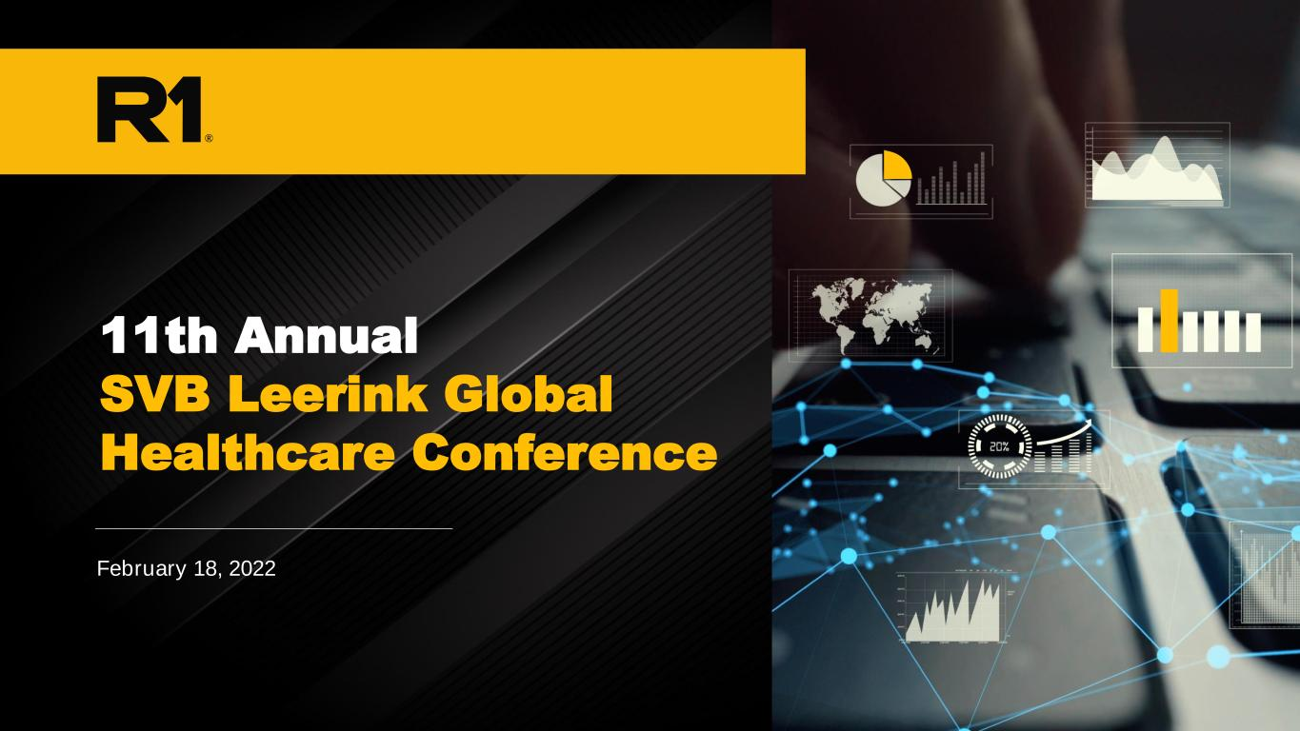
• January 10, 2022February 18, 2 22 11th Annual SVB Leerink Global Healthcare Conference NEED NEW IMAGE THAT WE SENT

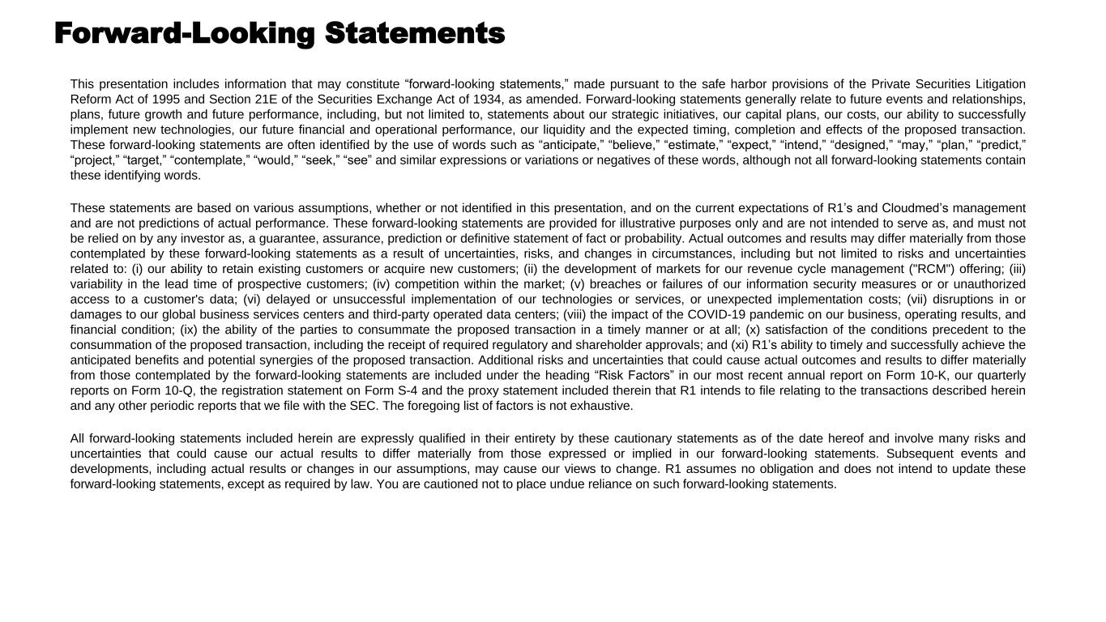
Forward-Looking Statements This presentation includes information that may constitute “forward-looking statements,” made pursuant to the safe harbor provisions of the Private Securities Litigation Reform Act of 1995 and Section 21E of the Securities Exchange Act of 1934, as amended. Forward-looking statements generally relate to future events and relationships, plans, future growth and future performance, including, but not limited to, statements about our strategic initiatives, our capital plans, our costs, our ability to successfully implement new technologies, our future financial and operational performance, our liquidity and the expected timing, completion and effects of the proposed transaction. These forward-looking statements are often identified by the use of words such as “anticipate,” “believe,” “estimate,” “expect,” “intend,” “designed,” “may,” “plan,” “predict,” “project,” “target,” “contemplate,” “would,” “seek,” “see” and similar expressions or variations or negatives of these words, although not all forward-looking statements contain these identifying words. These statements are based on various assumptions, whether or not identified in this presentation, and on the current expectations of R1’s and Cloudmed’s management and are not predictions of actual performance. These forward-looking statements are provided for illustrative purposes only and are not intended to serve as, and must not be relied on by any investor as, a guarantee, assurance, prediction or definitive statement of fact or probability. Actual outcomes and results may differ materially from those contemplated by these forward-looking statements as a result of uncertainties, risks, and changes in circumstances, including but not limited to risks and uncertainties related to: (i) our ability to retain existing customers or acquire new customers; (ii) the development of markets for our revenue cycle management ("RCM") offering; (iii) variability in the lead time of prospective customers; (iv) competition within the market; (v) breaches or failures of our information security measures or or unauthorized access to a customer's data; (vi) delayed or unsuccessful implementation of our technologies or services, or unexpected implementation costs; (vii) disruptions in or damages to our global business services centers and third-party operated data centers; (viii) the impact of the COVID-19 pandemic on our business, operating results, and financial condition; (ix) the ability of the parties to consummate the proposed transaction in a timely manner or at all; (x) satisfaction of the conditions precedent to the consummation of the proposed transaction, including the receipt of required regulatory and shareholder approvals; and (xi) R1’s ability to timely and successfully achieve the anticipated benefits and potential synergies of the proposed transaction. Additional risks and uncertainties that could cause actual outcomes and results to differ materially from those contemplated by the forward-looking statements are included under the heading “Risk Factors” in our most recent annual report on Form 10-K, our quarterly reports on Form 10-Q, the registration statement on Form S-4 and the proxy statement included therein that R1 intends to file relating to the transactions described herein and any other periodic reports that we file with the SEC. The foregoing list of factors is not exhaustive. All forward-looking statements included herein are expressly qualified in their entirety by these cautionary statements as of the date hereof and involve many risks and uncertainties that could cause our actual results to differ materially from those expressed or implied in our forward-looking statements. Subsequent events and developments, including actual results or changes in our assumptions, may cause our views to change. R1 assumes no obligation and does not intend to update these forward-looking statements, except as required by law. You are cautioned not to place undue reliance on such forward-looking statements.

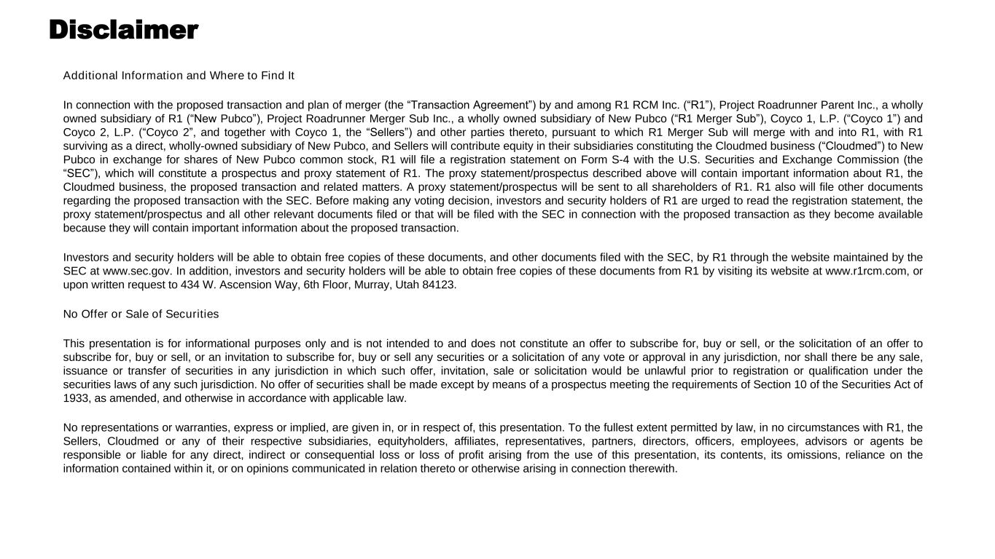
Disclaimer Additional Information and Where to Find It In connection with the proposed transaction and plan of merger (the “Transaction Agreement”) by and among R1 RCM Inc. (“R1”), Project Roadrunner Parent Inc., a wholly owned subsidiary of R1 (“New Pubco”), Project Roadrunner Merger Sub Inc., a wholly owned subsidiary of New Pubco (“R1 Merger Sub”), Coyco 1, L.P. (“Coyco 1”) and Coyco 2, L.P. (“Coyco 2”, and together with Coyco 1, the “Sellers”) and other parties thereto, pursuant to which R1 Merger Sub will merge with and into R1, with R1 surviving as a direct, wholly-owned subsidiary of New Pubco, and Sellers will contribute equity in their subsidiaries constituting the Cloudmed business (“Cloudmed”) to New Pubco in exchange for shares of New Pubco common stock, R1 will file a registration statement on Form S-4 with the U.S. Securities and Exchange Commission (the “SEC”), which will constitute a prospectus and proxy statement of R1. The proxy statement/prospectus described above will contain important information about R1, the Cloudmed business, the proposed transaction and related matters. A proxy statement/prospectus will be sent to all shareholders of R1. R1 also will file other documents regarding the proposed transaction with the SEC. Before making any voting decision, investors and security holders of R1 are urged to read the registration statement, the proxy statement/prospectus and all other relevant documents filed or that will be filed with the SEC in connection with the proposed transaction as they become available because they will contain important information about the proposed transaction. Investors and security holders will be able to obtain free copies of these documents, and other documents filed with the SEC, by R1 through the website maintained by the SEC at www.sec.gov. In addition, investors and security holders will be able to obtain free copies of these documents from R1 by visiting its website at www.r1rcm.com, or upon written request to 434 W. Ascension Way, 6th Floor, Murray, Utah 84123. No Offer or Sale of Securities This presentation is for informational purposes only and is not intended to and does not constitute an offer to subscribe for, buy or sell, or the solicitation of an offer to subscribe for, buy or sell, or an invitation to subscribe for, buy or sell any securities or a solicitation of any vote or approval in any jurisdiction, nor shall there be any sale, issuance or transfer of securities in any jurisdiction in which such offer, invitation, sale or solicitation would be unlawful prior to registration or qualification under the securities laws of any such jurisdiction. No offer of securities shall be made except by means of a prospectus meeting the requirements of Section 10 of the Securities Act of 1933, as amended, and otherwise in accordance with applicable law. No representations or warranties, express or implied, are given in, or in respect of, this presentation. To the fullest extent permitted by law, in no circumstances with R1, the Sellers, Cloudmed or any of their respective subsidiaries, equityholders, affiliates, representatives, partners, directors, officers, employees, advisors or agents be responsible or liable for any direct, indirect or consequential loss or loss of profit arising from the use of this presentation, its contents, its omissions, reliance on the information contained within it, or on opinions communicated in relation thereto or otherwise arising in connection therewith.

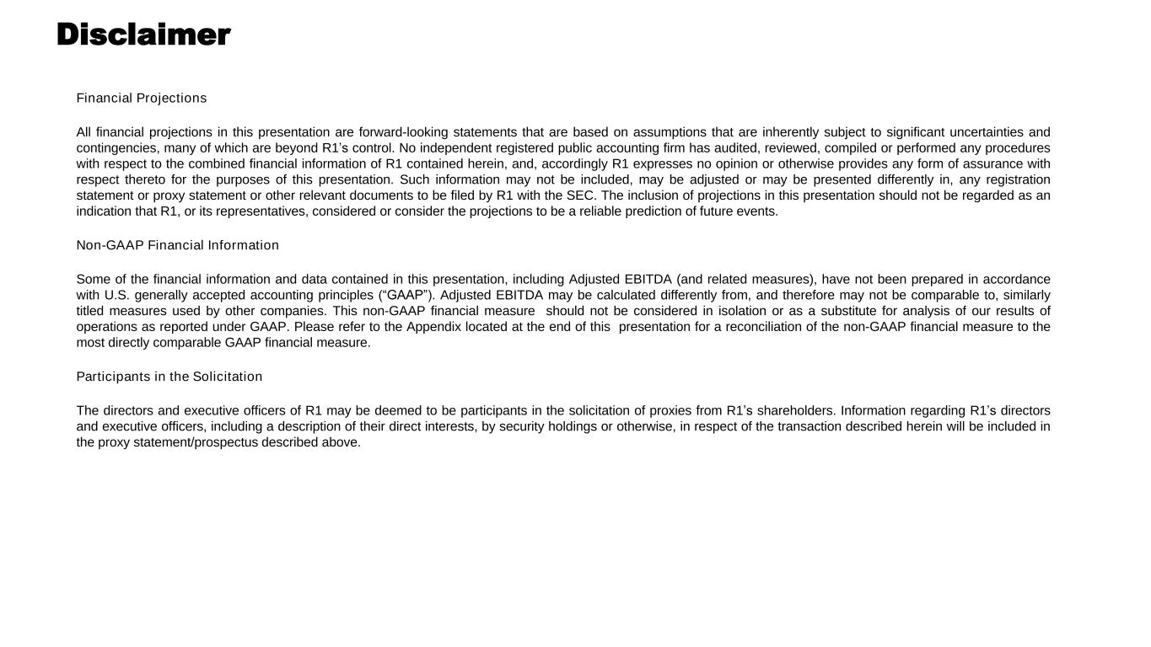
Disclaimer Financial Projections All financial projections in this presentation are forward-looking statements that are based on assumptions that are inherently subject to significant uncertainties and contingencies, many of which are beyond R1’s control. No independent registered public accounting firm has audited, reviewed, compiled or performed any procedures with respect to the combined financial information of R1 contained herein, and, accordingly R1 expresses no opinion or otherwise provides any form of assurance with respect thereto for the purposes of this presentation. Such information may not be included, may be adjusted or may be presented differently in, any registration statement or proxy statement or other relevant documents to be filed by R1 with the SEC. The inclusion of projections in this presentation should not be regarded as an indication that R1, or its representatives, considered or consider the projections to be a reliable prediction of future events. Non-GAAP Financial Information Some of the financial information and data contained in this presentation, including Adjusted EBITDA (and related measures), have not been prepared in accordance with U.S. generally accepted accounting principles (“GAAP”). Adjusted EBITDA may be calculated differently from, and therefore may not be comparable to, similarly titled measures used by other companies. This non-GAAP financial measure should not be considered in isolation or as a substitute for analysis of our results of operations as reported under GAAP. Please refer to the Appendix located at the end of this presentation for a reconciliation of the non-GAAP financial measure to the most directly comparable GAAP financial measure. Participants in the Solicitation The directors and executive officers of R1 may be deemed to be participants in the solicitation of proxies from R1’s shareholders. Information regarding R1’s directors and executive officers, including a description of their direct interests, by security holdings or otherwise, in respect of the transaction described herein will be included in the proxy statement/prospectus described above.

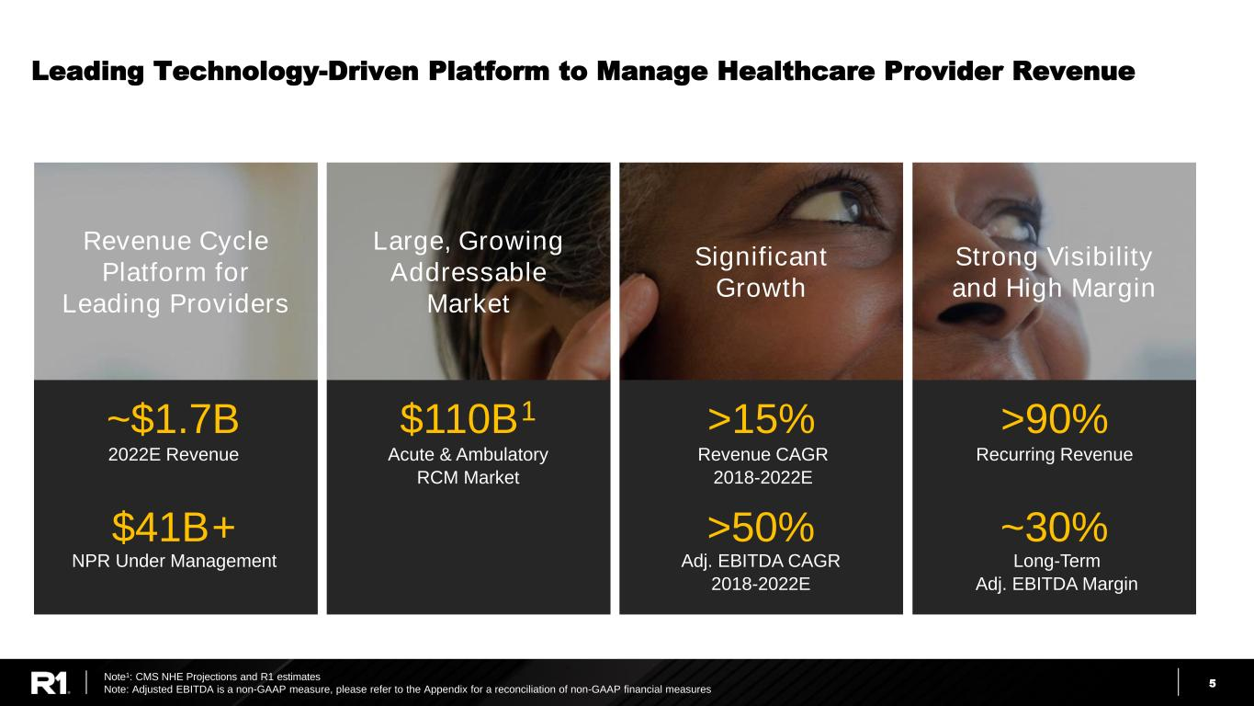
5 Leading Technology-Driven Platform to Manage Healthcare Provider Revenue Note1: CMS NHE Projections and R1 estimates Note: Adjusted EBITDA is a non-GAAP measure, please refer to the Appendix for a reconciliation of non-GAAP financial measures NPR Under Management ~$1.7B Revenue CAGR 2018-2022E >15% Revenue Cycle Platform for Leading Providers Large, Growing Addressable Market Significant Growth Strong Visibility and High Margin Recurring Revenue >90% Adj. EBITDA CAGR 2018-2022E >50% Long-Term Adj. EBITDA Margin ~30%$41B+ 2022E Revenue $110B1 Acute & Ambulatory RCM Market

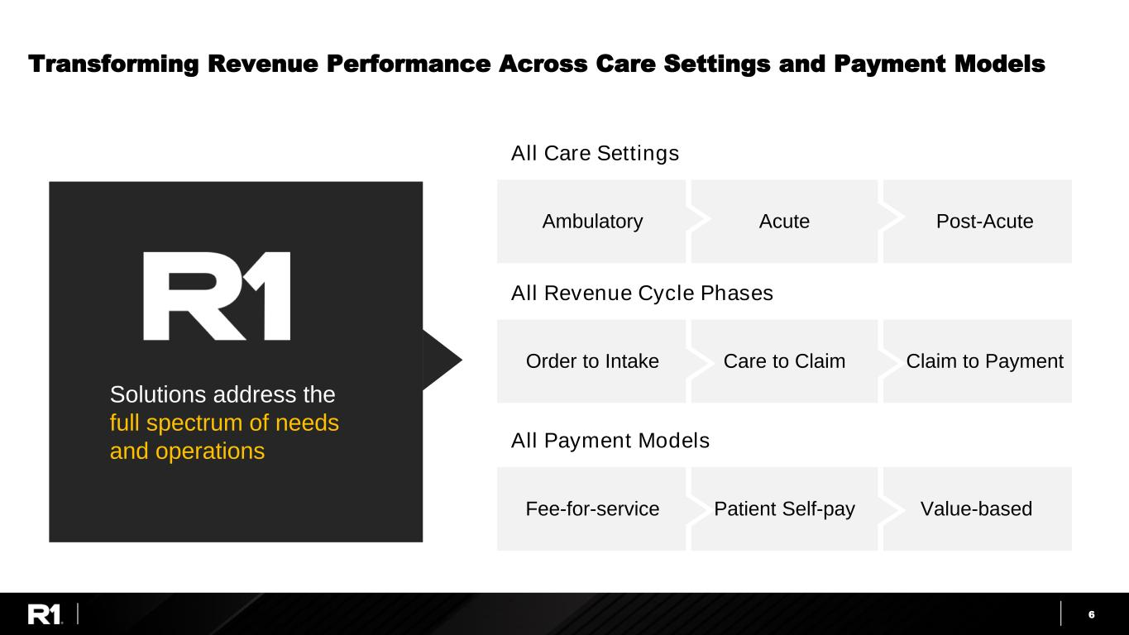
6 Transforming Revenue Performance Across Care Settings and Payment Models All Revenue Cycle Phases Order to Intake Care to Claim Claim to Payment All Payment Models Fee-for-service Patient Self-pay Value-based Solutions address the full spectrum of needs and operations All Care Settings Ambulatory Acute Post-Acute

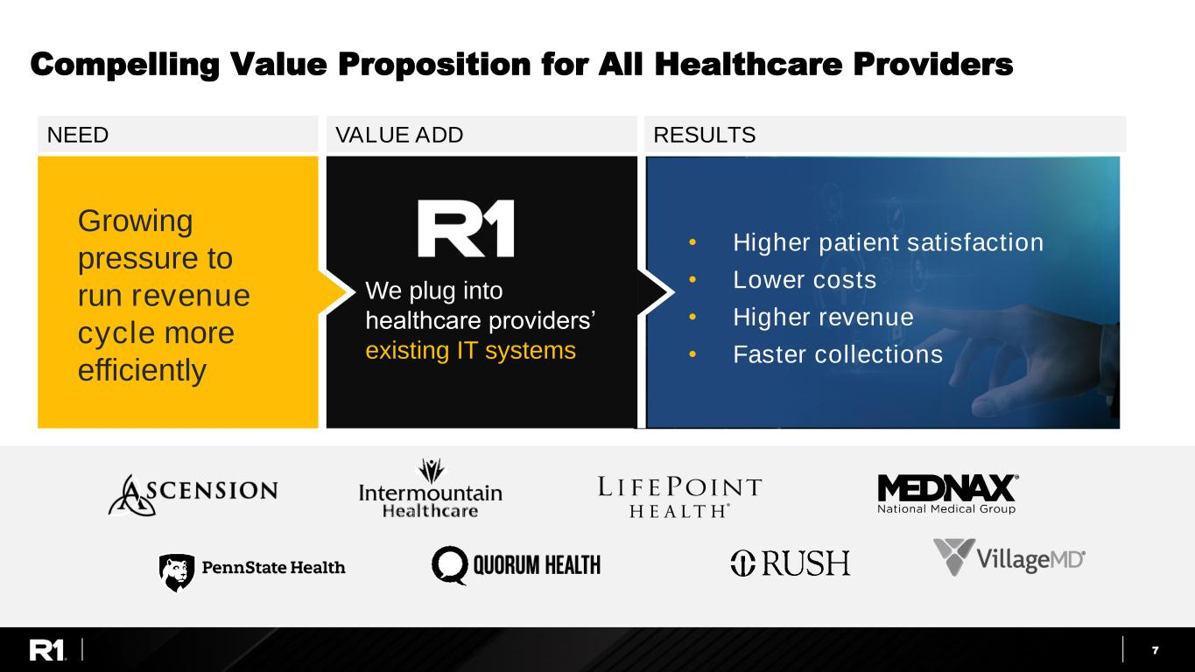
7 Compelling Value Proposition for All Healthcare Providers NEED • Higher patient satisfaction • Lower costs • Higher revenue • Faster collections Growing pressure to run revenue cycle more efficiently We plug into healthcare providers’ existing IT systems VALUE ADD RESULTS

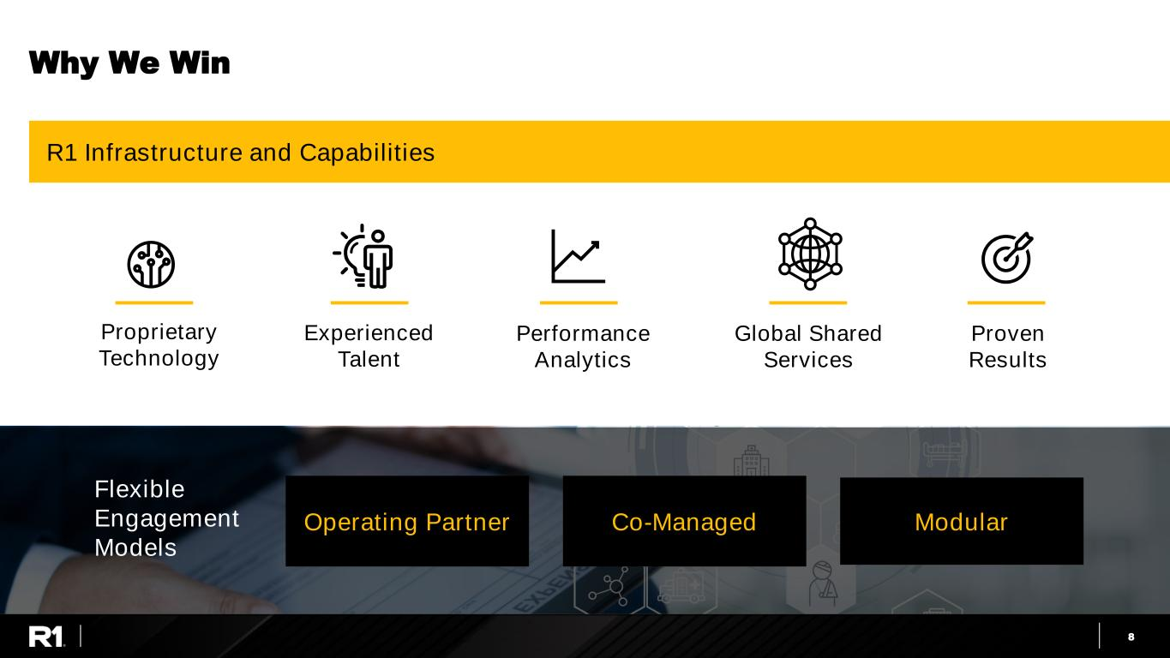
8 Why We Win Flexible Engagement Models Operating Partner Co-Managed Modular Proven Results R1 Infrastructure and Capabilities Proprietary Technology Experienced Talent Performance Analytics Global Shared Services

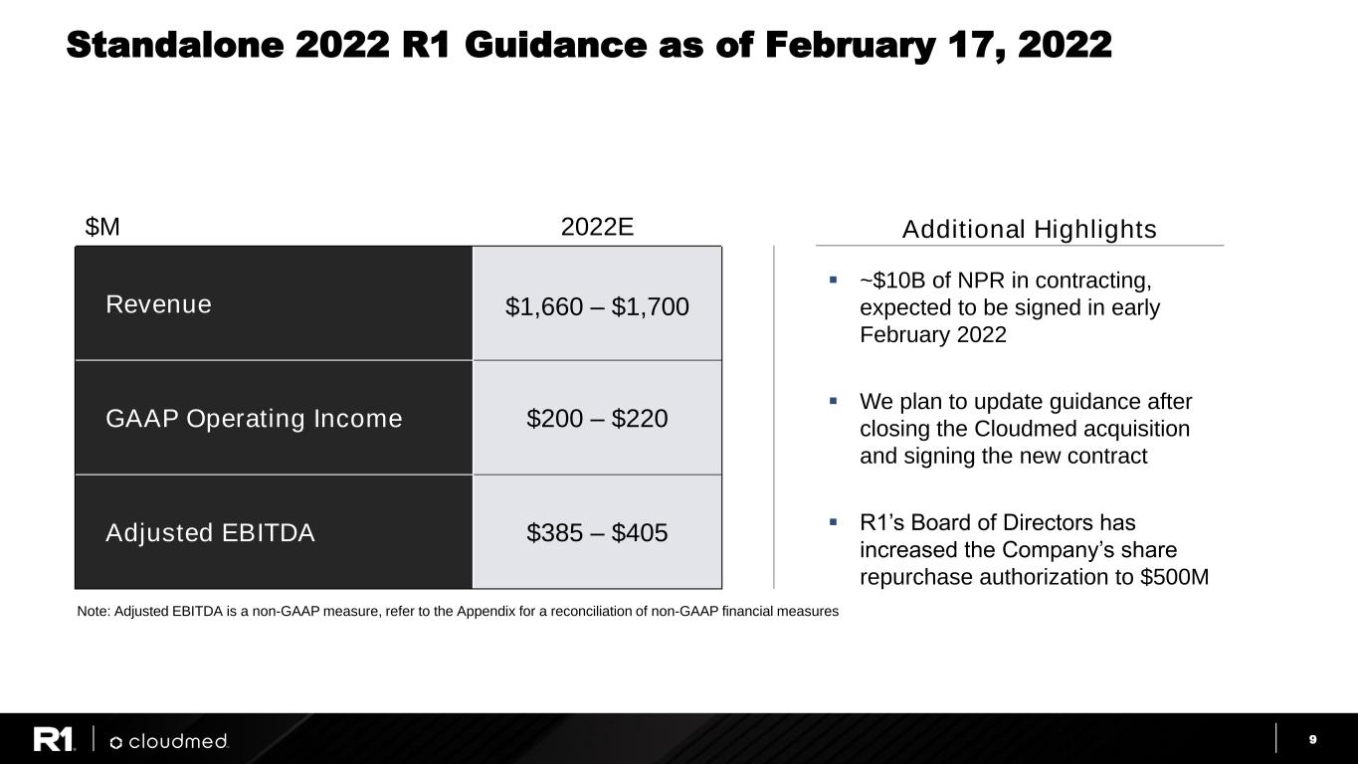
9 ▪ ~$10B of NPR in contracting, expected to be signed in early February 2022 ▪ We plan to update guidance after closing the Cloudmed acquisition and signing the new contract ▪ R1’s Board of Directors has increased the Company’s share repurchase authorization to $500M Standalone 2022 R1 Guidance as of February 17, 2022 $M 2022E Revenue $1,660 – $1,700 GAAP Operating Income $200 – $220 Adjusted EBITDA $385 – $405 Additional Highlights Note: Adjusted EBITDA is a non-GAAP measure, refer to the Appendix for a reconciliation of non-GAAP financial measures

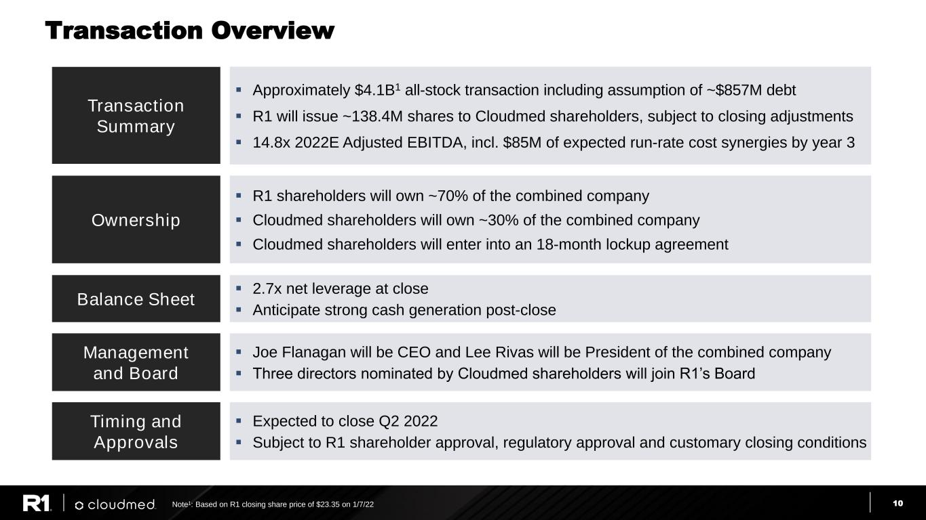
10 Timing and Approvals ▪ Expected to close Q2 2022 ▪ Subject to R1 shareholder approval, regulatory approval and customary closing conditions Management and Board ▪ Joe Flanagan will be CEO and Lee Rivas will be President of the combined company ▪ Three directors nominated by Cloudmed shareholders will join R1’s Board Ownership ▪ R1 shareholders will own ~70% of the combined company ▪ Cloudmed shareholders will own ~30% of the combined company ▪ Cloudmed shareholders will enter into an 18-month lockup agreement Transaction Summary ▪ Approximately $4.1B1 all-stock transaction including assumption of ~$857M debt ▪ R1 will issue ~138.4M shares to Cloudmed shareholders, subject to closing adjustments ▪ 14.8x 2022E Adjusted EBITDA, incl. $85M of expected run-rate cost synergies by year 3 Balance Sheet ▪ 2.7x net leverage at close ▪ Anticipate strong cash generation post-close Transaction Overview Note1: Based on R1 closing share price of $23.35 on 1/7/22

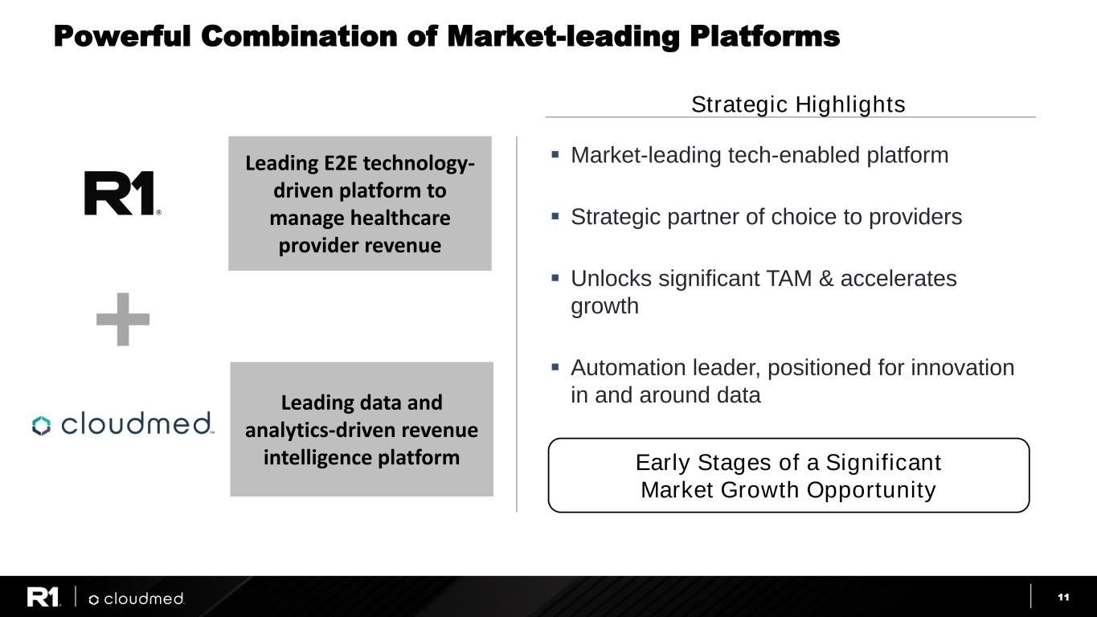
11 Leading data and analytics-driven revenue intelligence platform Leading E2E technology- driven platform to manage healthcare provider revenue Powerful Combination of Market-leading Platforms ▪ Market-leading tech-enabled platform ▪ Strategic partner of choice to providers ▪ Unlocks significant TAM & accelerates growth ▪ Automation leader, positioned for innovation in and around data Strategic Highlights Early Stages of a Significant Market Growth Opportunity

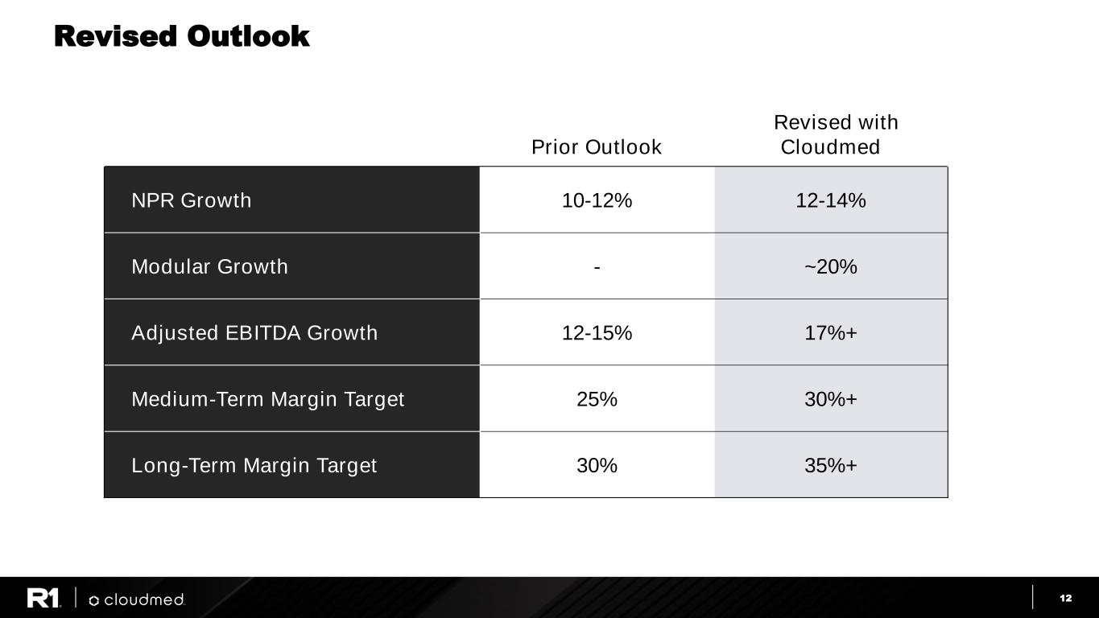
12 Revised Outlook Prior Outlook Revised with Cloudmed NPR Growth 10-12% 12-14% Modular Growth - ~20% Adjusted EBITDA Growth 12-15% 17%+ Medium-Term Margin Target 25% 30%+ Long-Term Margin Target 30% 35%+

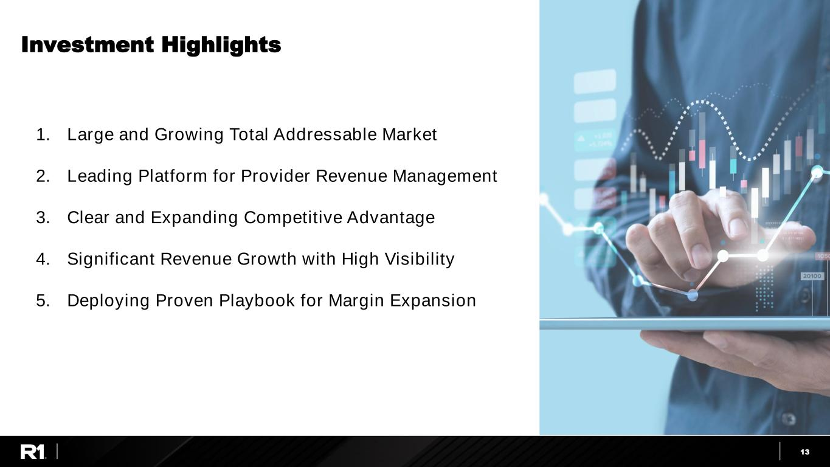
13 Investment Highlights 1. Large and Growing Total Addressable Market 2. Leading Platform for Provider Revenue Management 3. Clear and Expanding Competitive Advantage 4. Significant Revenue Growth with High Visibility 5. Deploying Proven Playbook for Margin Expansion

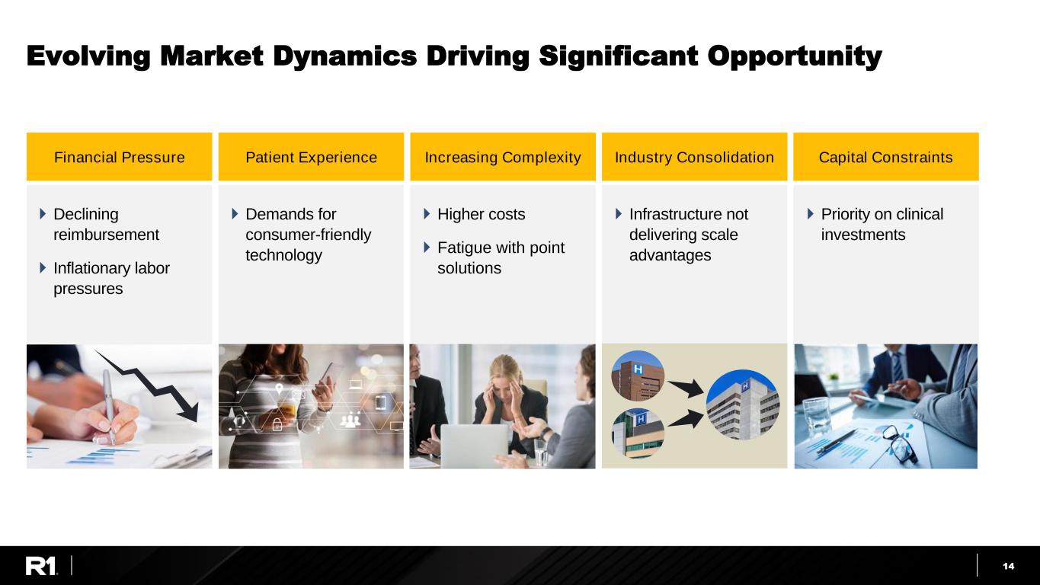
14 Evolving Market Dynamics Driving Significant Opportunity Industry Consolidation  Infrastructure not delivering scale advantages Capital Constraints  Priority on clinical investments Financial Pressure  Declining reimbursement  Inflationary labor pressures Increasing Complexity  Higher costs  Fatigue with point solutions Patient Experience  Demands for consumer-friendly technology

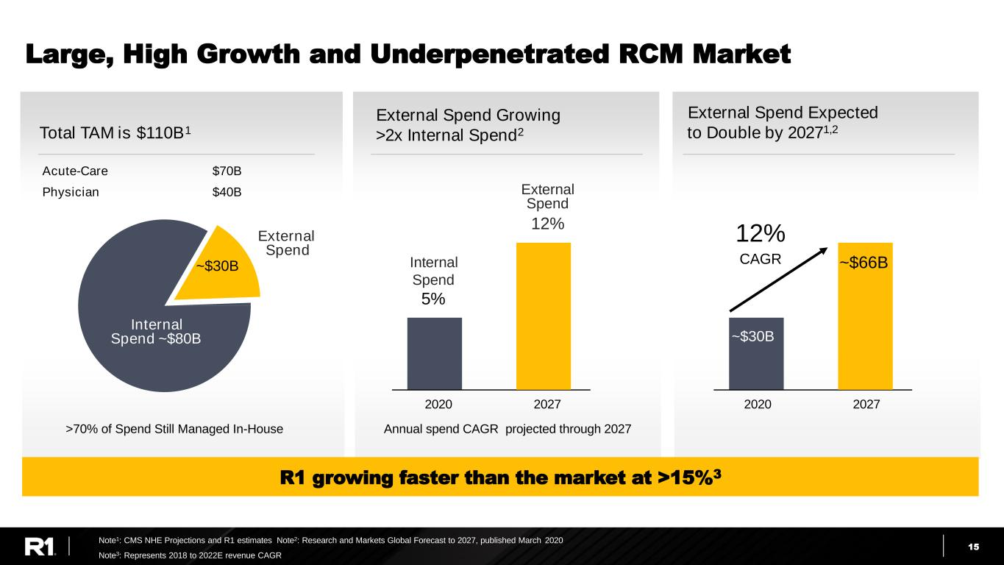
15 Total TAM is $110B1 Large, High Growth and Underpenetrated RCM Market External Spend ~$30B Internal Spend ~$80B Acute-Care $70B Physician $40B External Spend Expected to Double by 20271,2 External Spend Growing >2x Internal Spend2 2020 >70% of Spend Still Managed In-House 2027 12% CAGR Note1: CMS NHE Projections and R1 estimates Note2: Research and Markets Global Forecast to 2027, published March 2020 Annual spend CAGR projected through 2027 External Spend 12% Internal Spend 5% Note3: Represents 2018 to 2022E revenue CAGR 3R1 growing faster than the market at >15%3 ~$66B ~$30B 2020 2027

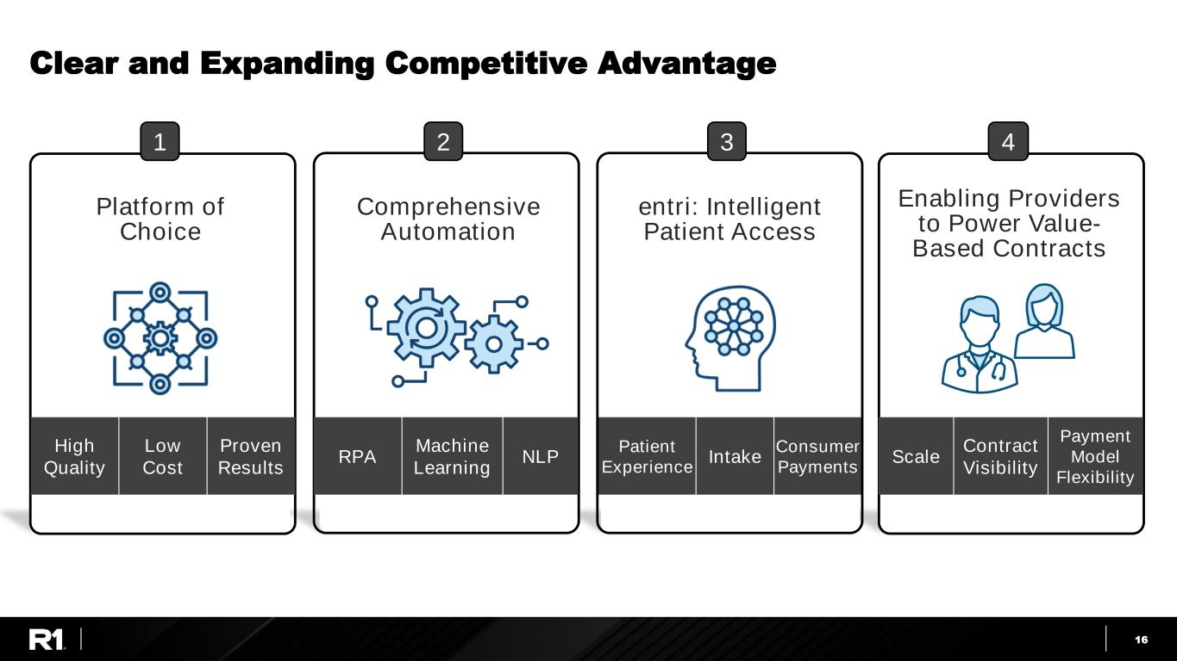
16 Clear and Expanding Competitive Advantage Platform of Choice Comprehensive Automation Enabling Providers to Power Value- Based Contracts High Quality Low Cost Proven Results Scale Contract Visibility Payment Model Flexibility 1 4 entri: Intelligent Patient Access Patient Experience Intake Consumer Payments 2 3 RPA Machine Learning NLP

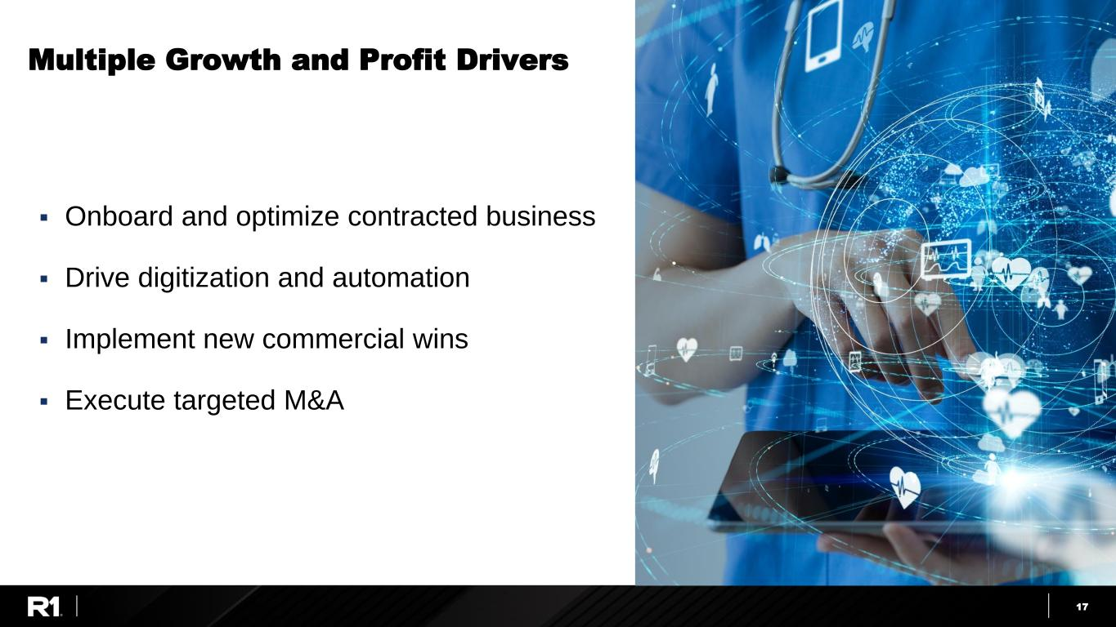
17 Multiple Growth and Profit Drivers ▪ Onboard and optimize contracted business ▪ Drive digitization and automation ▪ Implement new commercial wins ▪ Execute targeted M&A

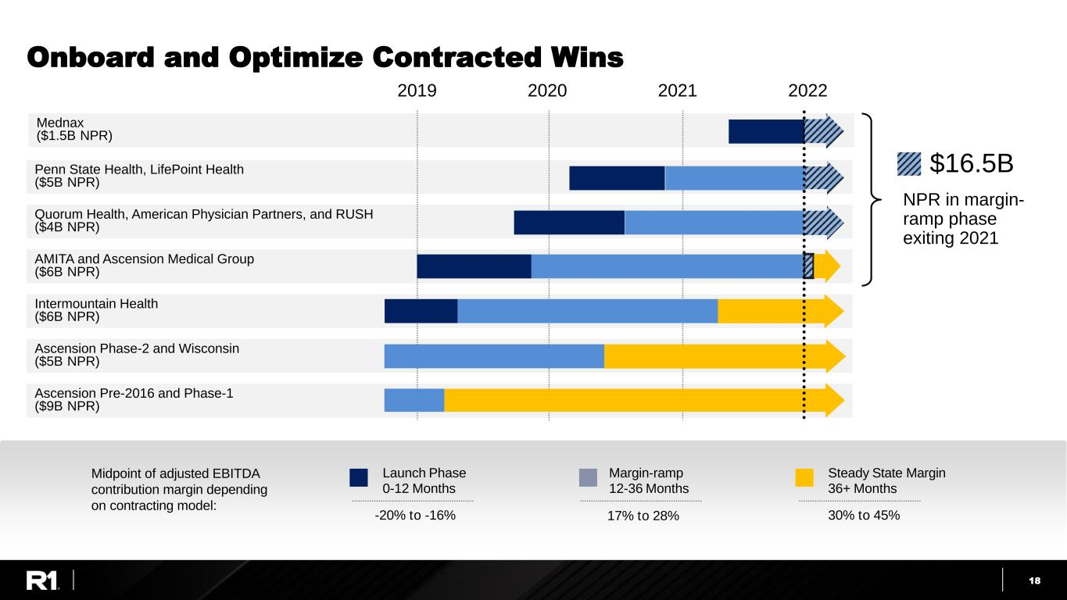
18 Onboard and Optimize Contracted Wins Midpoint of adjusted EBITDA contribution margin depending on contracting model: 30% to 45% Steady State Margin 36+ Months 17% to 28% Margin-ramp 12-36 Months -20% to -16% Launch Phase 0-12 Months Mednax ($1.5B NPR) Ascension Pre-2016 and Phase-1 ($9B NPR) Ascension Phase-2 and Wisconsin ($5B NPR) AMITA and Ascension Medical Group ($6B NPR) Quorum Health, American Physician Partners, and RUSH ($4B NPR) Penn State Health, LifePoint Health ($5B NPR) Intermountain Health ($6B NPR) 2019 2020 2021 2022 $16.5B NPR in margin- ramp phase exiting 2021

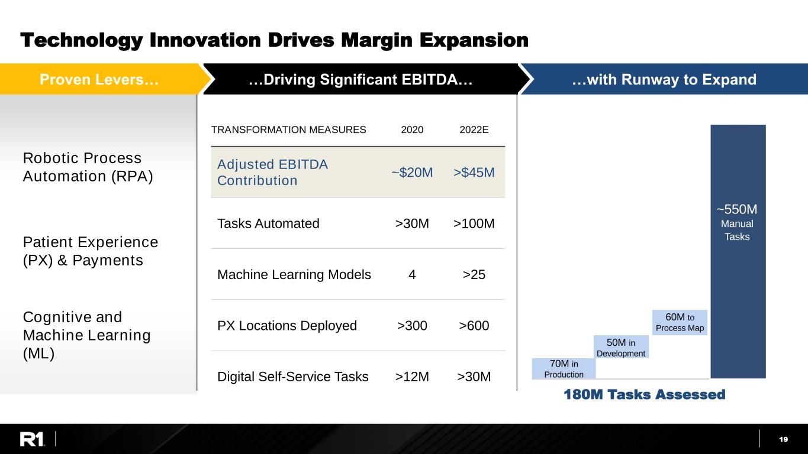
19 Technology Innovation Drives Margin Expansion TRANSFORMATION MEASURES 2020 2022E Adjusted EBITDA Contribution ~$20M >$45M Tasks Automated >30M >100M Machine Learning Models 4 >25 PX Locations Deployed >300 >600 Digital Self-Service Tasks >12M >30M …Driving Significant EBITDA… …with Runway to ExpandProven Levers… 180M Tasks Assessed 50M in Development 70M in Production Manual Tasks ~550M 60M to Process Map Robotic Process Automation (RPA) Patient Experience (PX) & Payments Cognitive and Machine Learning (ML)

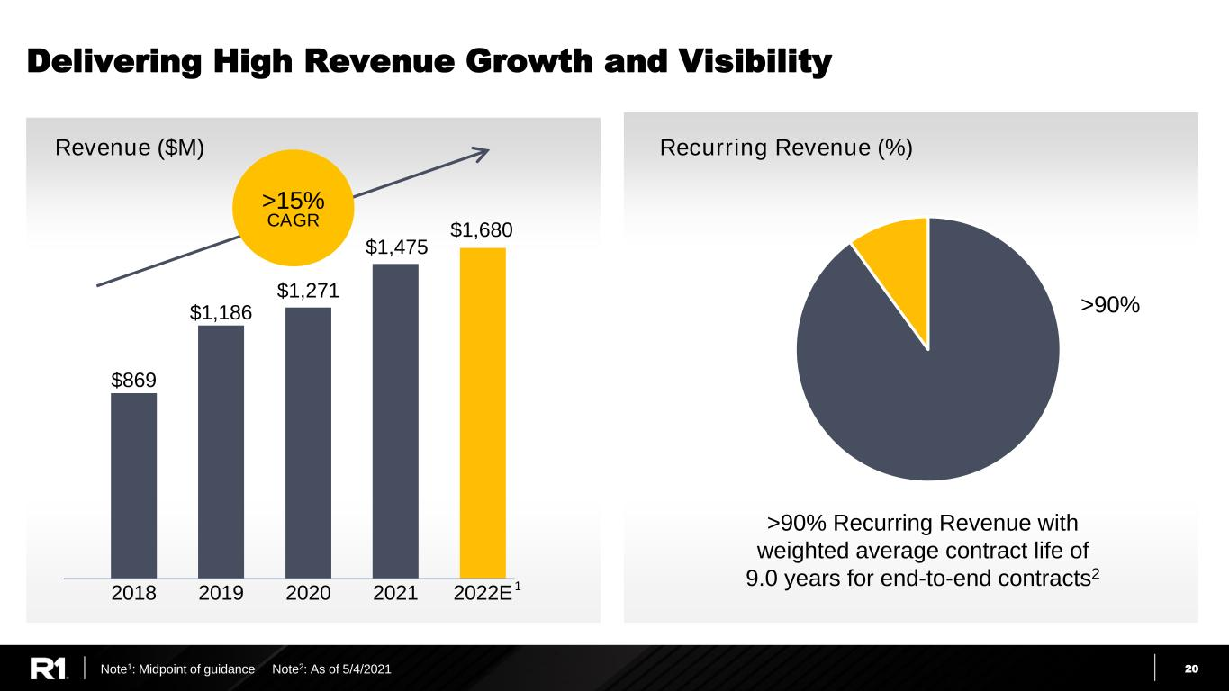
20 Delivering High Revenue Growth and Visibility Revenue ($M) $869 $1,186 $1,271 $1,475 2018 2019 2020 2021 2022E $1,680 >15% CAGR >90% >90% Recurring Revenue with weighted average contract life of 9.0 years for end-to-end contracts2 Note1: Midpoint of guidance Note2: As of 5/4/2021 1 Recurring Revenue (%)

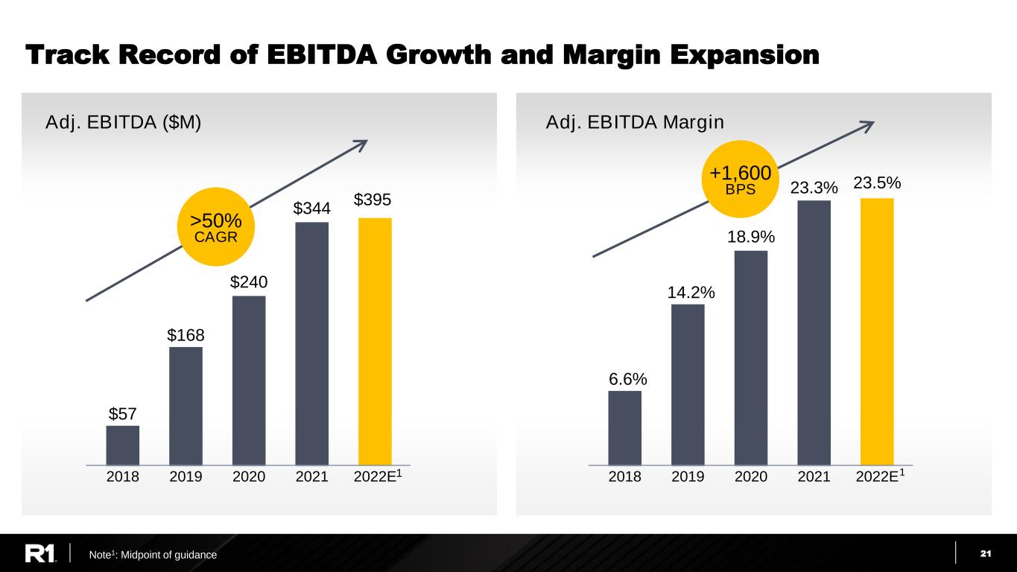
21 6.6% 14.2% 18.9% 23.3% 23.5% 2018 2019 2020 2021 2022E $57 $168 $240 $344 2018 2019 2020 2021 2022E Track Record of EBITDA Growth and Margin Expansion >50% CAGR 1 Note1: Midpoint of guidance 1 Adj. EBITDA ($M) Adj. EBITDA Margin +1,600 BPS $395

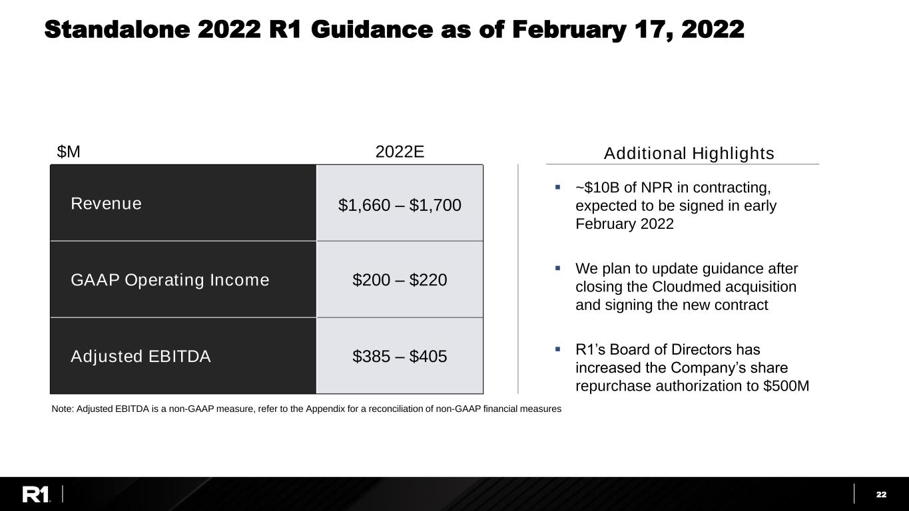
22 ▪ ~$10B of NPR in contracting, expected to be signed in early February 2022 ▪ We plan to update guidance after closing the Cloudmed acquisition and signing the new contract ▪ R1’s Board of Directors has increased the Company’s share repurchase authorization to $500M Standalone 2022 R1 Guidance as of February 17, 2022 $M 2022E Revenue $1,660 – $1,700 GAAP Operating Income $200 – $220 Adjusted EBITDA $385 – $405 Additional Highlights Note: Adjusted EBITDA is a non-GAAP measure, refer to the Appendix for a reconciliation of non-GAAP financial measures

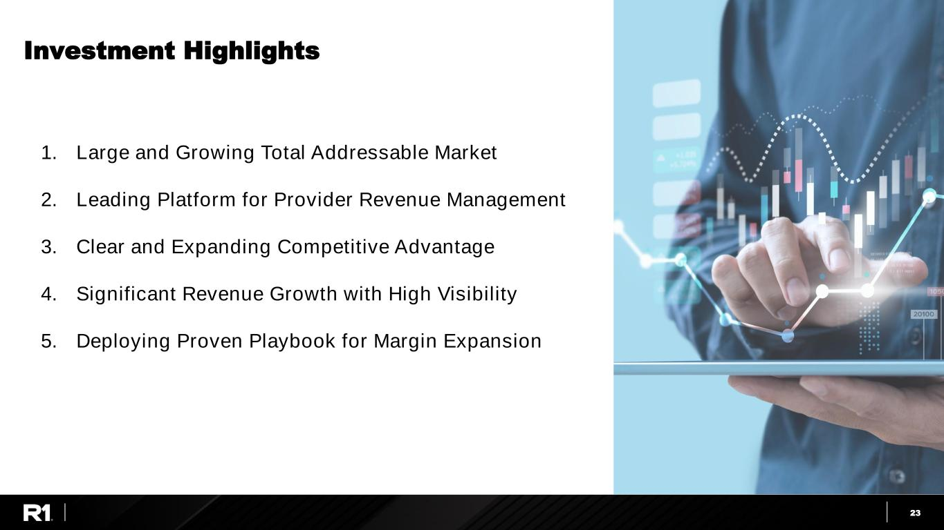
23 Investment Highlights 1. Large and Growing Total Addressable Market 2. Leading Platform for Provider Revenue Management 3. Clear and Expanding Competitive Advantage 4. Significant Revenue Growth with High Visibility 5. Deploying Proven Playbook for Margin Expansion


24JPM Healthcare Conference 2022 Appendix

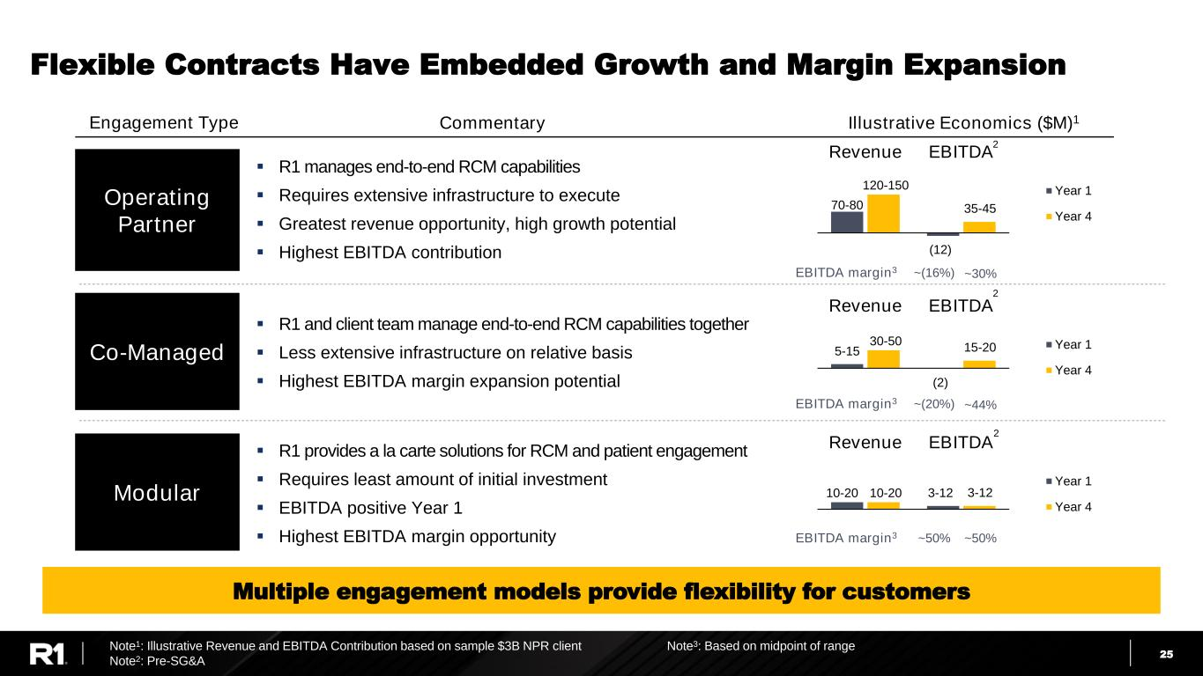
25 Flexible Contracts Have Embedded Growth and Margin Expansion EBITDA margin3 Operating Partner Co-Managed Modular Engagement Type Commentary Illustrative Economics ($M)1 ▪ R1 manages end-to-end RCM capabilities ▪ Requires extensive infrastructure to execute ▪ Greatest revenue opportunity, high growth potential ▪ Highest EBITDA contribution ▪ R1 and client team manage end-to-end RCM capabilities together ▪ Less extensive infrastructure on relative basis ▪ Highest EBITDA margin expansion potential ▪ R1 provides a la carte solutions for RCM and patient engagement ▪ Requires least amount of initial investment ▪ EBITDA positive Year 1 ▪ Highest EBITDA margin opportunity 70-80 (12) 120-150 35-45 Revenue EBITDA Year 1 Year 4 5-15 (2) 30-50 15-20 Revenue EBITDA Year 1 Year 4 10-20 3-1210-20 3-12 Revenue EBITDA Year 1 Year 4 2 2 2 EBITDA margin3 ~(20%) ~44% EBITDA margin3 ~50% ~50% ~(16%) ~30% Note1: Illustrative Revenue and EBITDA Contribution based on sample $3B NPR client Note2: Pre-SG&A Note3: Based on midpoint of range Multiple engagement models provide flexibility for customers

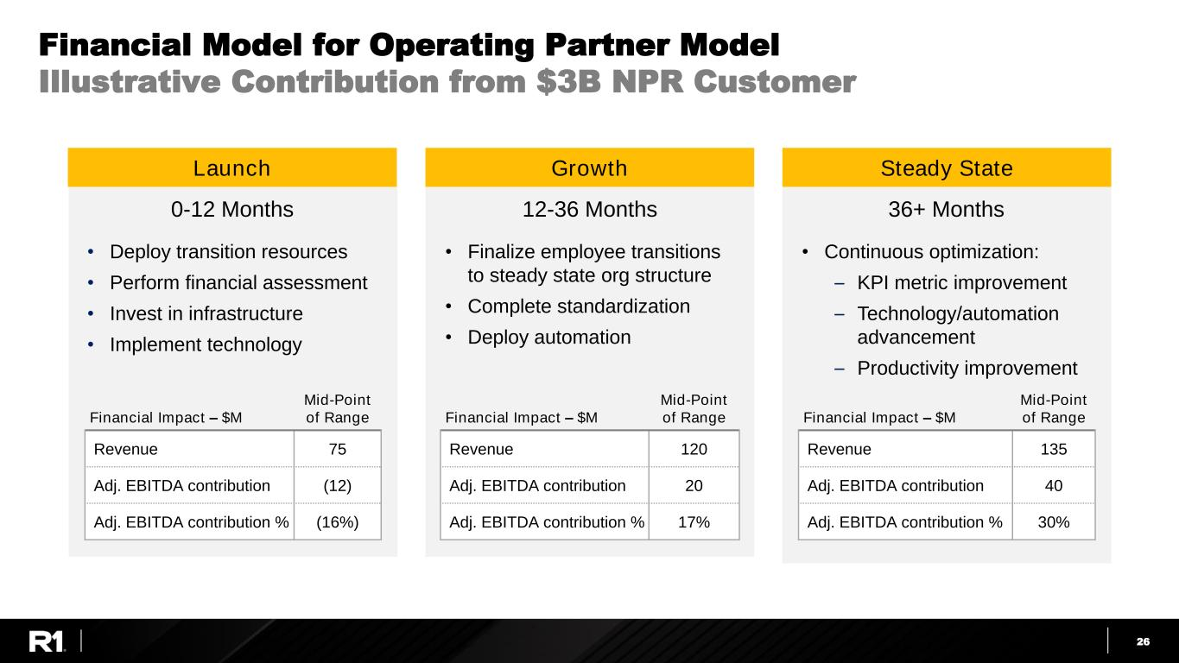
26 Financial Model for Operating Partner Model Illustrative Contribution from $3B NPR Customer Growth • Deploy transition resources • Perform financial assessment • Invest in infrastructure • Implement technology • Finalize employee transitions to steady state org structure • Complete standardization • Deploy automation • Continuous optimization: – KPI metric improvement – Technology/automation advancement – Productivity improvement Financial Impact – $M Mid-Point of Range Revenue 120 Adj. EBITDA contribution 20 Adj. EBITDA contribution % 17% Launch Steady State Financial Impact – $M Mid-Point of Range Revenue 75 Adj. EBITDA contribution (12) Adj. EBITDA contribution % (16%) Financial Impact – $M Mid-Point of Range Revenue 135 Adj. EBITDA contribution 40 Adj. EBITDA contribution % 30% 0-12 Months 12-36 Months 36+ Months

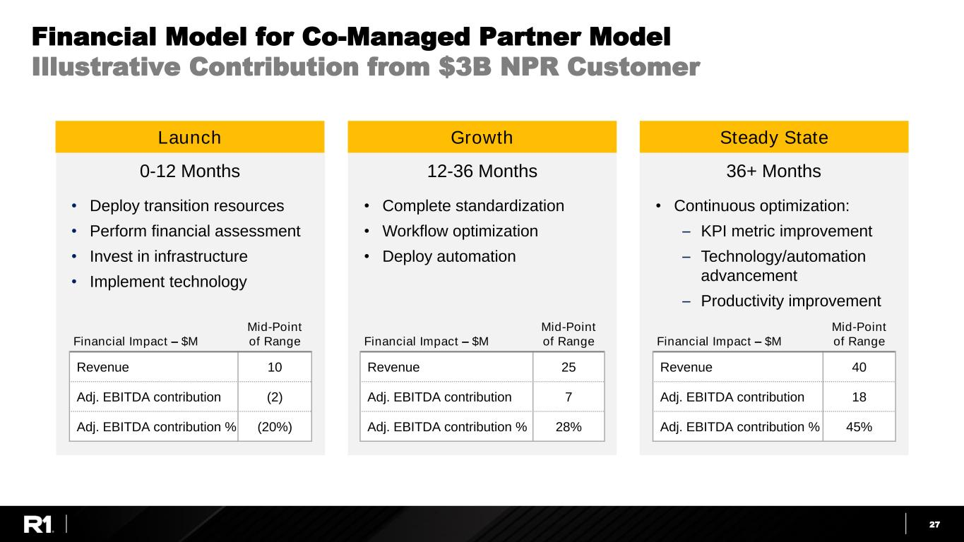
27 Financial Model for Co-Managed Partner Model Illustrative Contribution from $3B NPR Customer • Deploy transition resources • Perform financial assessment • Invest in infrastructure • Implement technology • Complete standardization • Workflow optimization • Deploy automation • Continuous optimization: – KPI metric improvement – Technology/automation advancement – Productivity improvement Financial Impact – $M Mid-Point of Range Revenue 25 Adj. EBITDA contribution 7 Adj. EBITDA contribution % 28% Financial Impact – $M Mid-Point of Range Revenue 10 Adj. EBITDA contribution (2) Adj. EBITDA contribution % (20%) Financial Impact – $M Mid-Point of Range Revenue 40 Adj. EBITDA contribution 18 Adj. EBITDA contribution % 45% 0-12 Months 12-36 Months 36+ Months GrowthLaunch Steady State

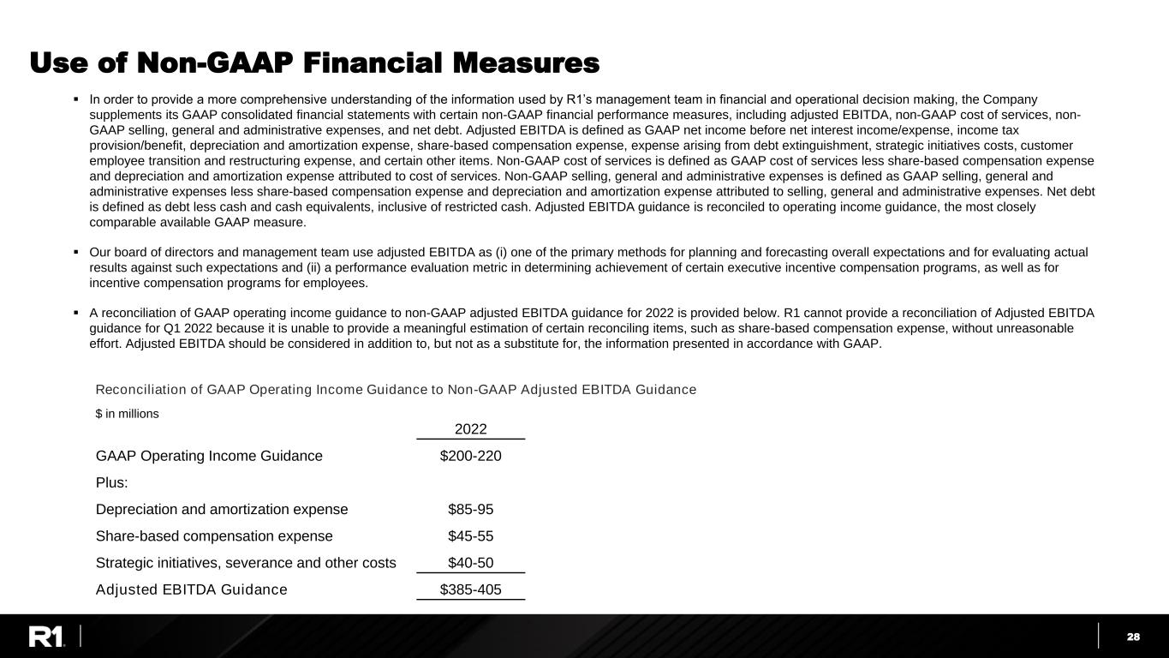
28 Use of Non-GAAP Financial Measures 2022 GAAP Operating Income Guidance $200-220 Plus: Depreciation and amortization expense $85-95 Share-based compensation expense $45-55 Strategic initiatives, severance and other costs $40-50 Adjusted EBITDA Guidance $385-405 Reconciliation of GAAP Operating Income Guidance to Non-GAAP Adjusted EBITDA Guidance $ in millions ▪ In order to provide a more comprehensive understanding of the information used by R1’s management team in financial and operational decision making, the Company supplements its GAAP consolidated financial statements with certain non-GAAP financial performance measures, including adjusted EBITDA, non-GAAP cost of services, non- GAAP selling, general and administrative expenses, and net debt. Adjusted EBITDA is defined as GAAP net income before net interest income/expense, income tax provision/benefit, depreciation and amortization expense, share-based compensation expense, expense arising from debt extinguishment, strategic initiatives costs, customer employee transition and restructuring expense, and certain other items. Non-GAAP cost of services is defined as GAAP cost of services less share-based compensation expense and depreciation and amortization expense attributed to cost of services. Non-GAAP selling, general and administrative expenses is defined as GAAP selling, general and administrative expenses less share-based compensation expense and depreciation and amortization expense attributed to selling, general and administrative expenses. Net debt is defined as debt less cash and cash equivalents, inclusive of restricted cash. Adjusted EBITDA guidance is reconciled to operating income guidance, the most closely comparable available GAAP measure. ▪ Our board of directors and management team use adjusted EBITDA as (i) one of the primary methods for planning and forecasting overall expectations and for evaluating actual results against such expectations and (ii) a performance evaluation metric in determining achievement of certain executive incentive compensation programs, as well as for incentive compensation programs for employees. ▪ A reconciliation of GAAP operating income guidance to non-GAAP adjusted EBITDA guidance for 2022 is provided below. R1 cannot provide a reconciliation of Adjusted EBITDA guidance for Q1 2022 because it is unable to provide a meaningful estimation of certain reconciling items, such as share-based compensation expense, without unreasonable effort. Adjusted EBITDA should be considered in addition to, but not as a substitute for, the information presented in accordance with GAAP.

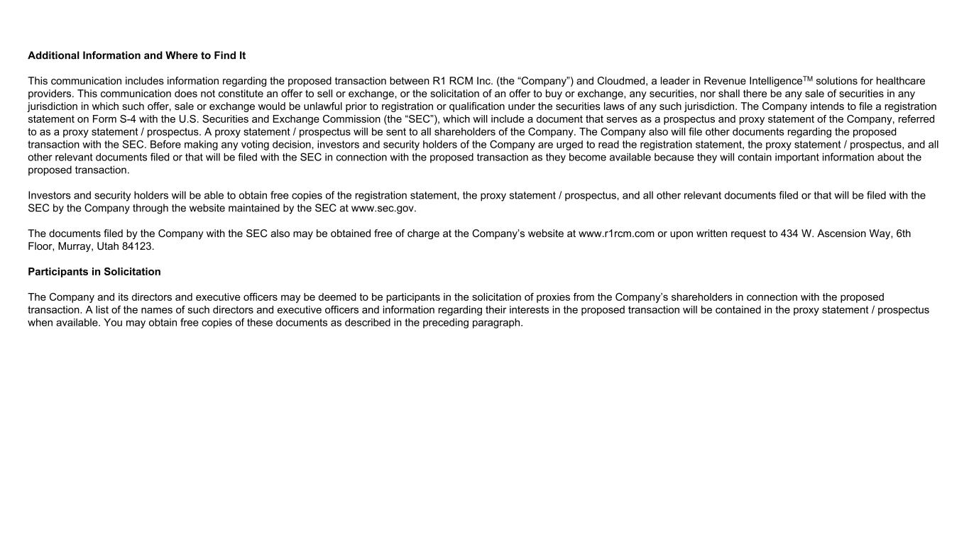
Additional Information and Where to Find It This communication includes information regarding the proposed transaction between R1 RCM Inc. (the “Company”) and Cloudmed, a leader in Revenue IntelligenceTM solutions for healthcare providers. This communication does not constitute an offer to sell or exchange, or the solicitation of an offer to buy or exchange, any securities, nor shall there be any sale of securities in any jurisdiction in which such offer, sale or exchange would be unlawful prior to registration or qualification under the securities laws of any such jurisdiction. The Company intends to file a registration statement on Form S-4 with the U.S. Securities and Exchange Commission (the “SEC”), which will include a document that serves as a prospectus and proxy statement of the Company, referred to as a proxy statement / prospectus. A proxy statement / prospectus will be sent to all shareholders of the Company. The Company also will file other documents regarding the proposed transaction with the SEC. Before making any voting decision, investors and security holders of the Company are urged to read the registration statement, the proxy statement / prospectus, and all other relevant documents filed or that will be filed with the SEC in connection with the proposed transaction as they become available because they will contain important information about the proposed transaction. Investors and security holders will be able to obtain free copies of the registration statement, the proxy statement / prospectus, and all other relevant documents filed or that will be filed with the SEC by the Company through the website maintained by the SEC at www.sec.gov. The documents filed by the Company with the SEC also may be obtained free of charge at the Company’s website at www.r1rcm.com or upon written request to 434 W. Ascension Way, 6th Floor, Murray, Utah 84123. Participants in Solicitation The Company and its directors and executive officers may be deemed to be participants in the solicitation of proxies from the Company’s shareholders in connection with the proposed transaction. A list of the names of such directors and executive officers and information regarding their interests in the proposed transaction will be contained in the proxy statement / prospectus when available. You may obtain free copies of these documents as described in the preceding paragraph.

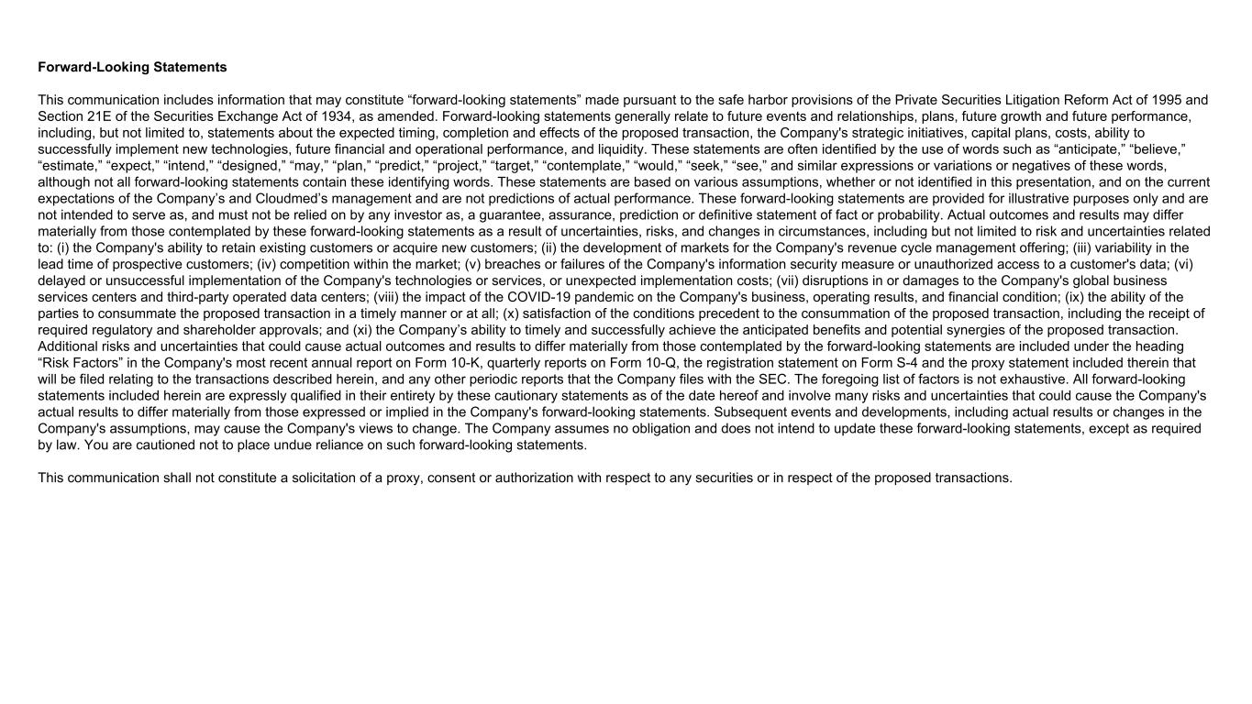
Forward-Looking Statements This communication includes information that may constitute “forward-looking statements” made pursuant to the safe harbor provisions of the Private Securities Litigation Reform Act of 1995 and Section 21E of the Securities Exchange Act of 1934, as amended. Forward-looking statements generally relate to future events and relationships, plans, future growth and future performance, including, but not limited to, statements about the expected timing, completion and effects of the proposed transaction, the Company's strategic initiatives, capital plans, costs, ability to successfully implement new technologies, future financial and operational performance, and liquidity. These statements are often identified by the use of words such as “anticipate,” “believe,” “estimate,” “expect,” “intend,” “designed,” “may,” “plan,” “predict,” “project,” “target,” “contemplate,” “would,” “seek,” “see,” and similar expressions or variations or negatives of these words, although not all forward-looking statements contain these identifying words. These statements are based on various assumptions, whether or not identified in this presentation, and on the current expectations of the Company’s and Cloudmed’s management and are not predictions of actual performance. These forward-looking statements are provided for illustrative purposes only and are not intended to serve as, and must not be relied on by any investor as, a guarantee, assurance, prediction or definitive statement of fact or probability. Actual outcomes and results may differ materially from those contemplated by these forward-looking statements as a result of uncertainties, risks, and changes in circumstances, including but not limited to risk and uncertainties related to: (i) the Company's ability to retain existing customers or acquire new customers; (ii) the development of markets for the Company's revenue cycle management offering; (iii) variability in the lead time of prospective customers; (iv) competition within the market; (v) breaches or failures of the Company's information security measure or unauthorized access to a customer's data; (vi) delayed or unsuccessful implementation of the Company's technologies or services, or unexpected implementation costs; (vii) disruptions in or damages to the Company's global business services centers and third-party operated data centers; (viii) the impact of the COVID-19 pandemic on the Company's business, operating results, and financial condition; (ix) the ability of the parties to consummate the proposed transaction in a timely manner or at all; (x) satisfaction of the conditions precedent to the consummation of the proposed transaction, including the receipt of required regulatory and shareholder approvals; and (xi) the Company’s ability to timely and successfully achieve the anticipated benefits and potential synergies of the proposed transaction. Additional risks and uncertainties that could cause actual outcomes and results to differ materially from those contemplated by the forward-looking statements are included under the heading “Risk Factors” in the Company's most recent annual report on Form 10-K, quarterly reports on Form 10-Q, the registration statement on Form S-4 and the proxy statement included therein that will be filed relating to the transactions described herein, and any other periodic reports that the Company files with the SEC. The foregoing list of factors is not exhaustive. All forward-looking statements included herein are expressly qualified in their entirety by these cautionary statements as of the date hereof and involve many risks and uncertainties that could cause the Company's actual results to differ materially from those expressed or implied in the Company's forward-looking statements. Subsequent events and developments, including actual results or changes in the Company's assumptions, may cause the Company's views to change. The Company assumes no obligation and does not intend to update these forward-looking statements, except as required by law. You are cautioned not to place undue reliance on such forward-looking statements. This communication shall not constitute a solicitation of a proxy, consent or authorization with respect to any securities or in respect of the proposed transactions.

